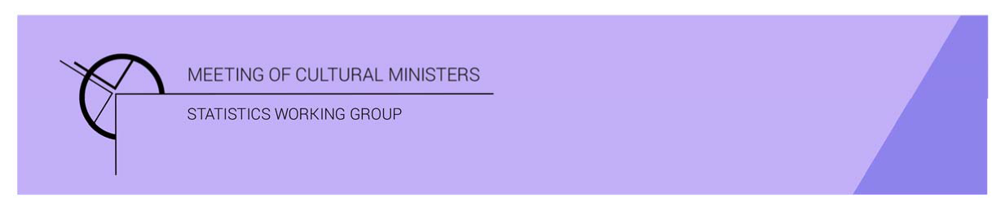

# Cultural Funding by Government — 2017–18

## Western Australian Government

The estimate of expenditure funded by the Western Australian Government in 2017–18 for cultural activities was **$296.8m**. This represented an increase of 1% or $3.0m from 2016–17.

Table 1—Western Australian Government cultural expenditure, 2015–16 to 2017–18

| 2015–16 | 2016–17 | 2017–18 |
| --- | --- | --- |
| $252.6m | $293.8m ↑ 16% | $296.8m ↑ 1% |

* Recurrent expenses accounted for 74% ($218.3m) of funded cultural expenditure.
* Capital expenditure was $78.5m, and the largest two categories were *Other museums and cultural heritage* ($67.6m) and *Libraries* ($8.9m).
* The estimate of per person cultural funding was $114.91.

Funds on *Heritage* activities rose 13% (or $20.7m) to $181.9m.

This increase was driven by expenditure on the categories of *Other museums and cultural heritage* (↑$22.4m) and *Libraries* (↑$2.3m). Increases were offset by a fall in *Archives* (↓$2.3m).

Over two-thirds (69%) of *Heritage* funds were spent on *Other museums and cultural heritage* ($124.7m)with an additional 25% spent on *Libraries* ($45.0m).

Figure 1. Western Australian Government heritage expenditure

Figure 1. Western Australian Government heritage expenditure.

A column graph compares expenditure across the heritage categories of Art museums, Other museums and cultural heritage, Libraries and Archives between the financial years of 2015-16, 2016-17 and 2017-18 for Western Australian Government.

Funds for *Arts* activities decreased 13% (or $17.6m) to $115.0m.

The main contributors to this movement were *Community arts and cultural development* ↓$12.6m, *Arts administration* ↓$7.4m and *Performing art venues* ↓$5.2m. Conversely, funding for *Multi-arts festivals* and *Cross-art form* rose by $4.4m and $4.1m respectively.

Figure 2. Western Australian Government arts expenditure, by selected categories

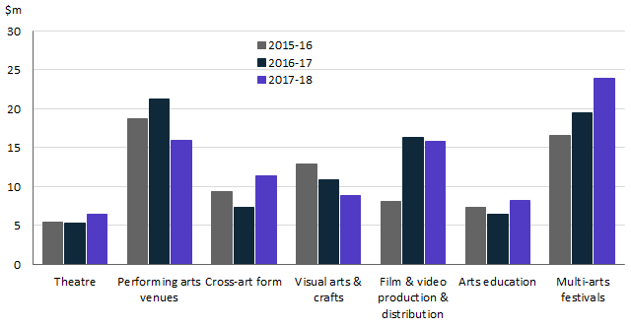

The main categories of *Arts* activities funding were:

* *Multi-arts festivals*—$23.9m
* *Performing art venues*—$15.9m
* *Film and video production and distribution*—$15.8m
* *Cross-art form*—$11.4m
* *Visual arts and crafts*—$8.9m.

Recurrent expenditure dropped 5% (or $11.0m) to $218.3m.

Table 2—Western Australian Government recurrent cultural expenditure, 2015–16 to 2017–18

| 2015–16 | 2016–17 | 2017–18 |
| --- | --- | --- |
| $201.3m | $229.3m ↑ 14% | $218.3m ↓ 5% |

* The largest recurrent expenditure was for *Other museums and cultural heritage*, $57.1m followed by *Libraries* ($36.0m).

Figure 3. Western Australian Government recurrent cultural expenditure, by selected categories

