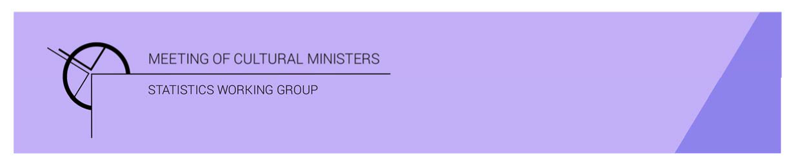

# Cultural Funding by Government — 2017–18

## Victorian Government

The estimate of expenditure funded by the Victorian Government in 2017–18 for cultural activities was **$547.1m**. This represented an increase of 11% or $54.5m from 2016–17.

Table 1—Victorian Government cultural expenditure, 2015–16 to 2017–18

| 2015–16 | 2016–17 | 2017–18 |
| --- | --- | --- |
| $477.5m | $492.6m ↑ 3% | $547.1m ↑ 11% |

* Recurrent expenses accounted for 82% ($447.6m) of funded cultural expenditure.
* Capital expenditure was $99.5m, and the largest three categories were *Libraries* ($44.1m), *Other museums and cultural heritage* ($22.4m) and *Performing art venues* ($18.4m).
* The estimate of per person cultural funding was $85.67.

Funds on *Heritage* activities rose 11% (or $29.6m) to $294.0m.

This increase was driven by expenditure on the categories of *Libraries* (↑$27.2m) and *Art Museums* (↑$7.3m). Increases were offset by a fall in *Other museums and cultural heritage* (↓$6m).

Over one-third (44%) of *Heritage* funds were spent on *Libraries* ($128.0m).

Figure 1. Victorian Government heritage expenditure

Figure 1. Victorian Government heritage expenditure.

A column graph compares expenditure across the heritage categories of Art museums, Other museums and cultural heritage, Libraries and Archives between the financial years of 2015-16, 2016-17 and 2017-18 for Victorian Government.

Funds for *Arts* activities rose 11% (or $24.9m) to $253.1m.

Three main contributors to this movement were *Performing arts venues* ↑$7.4m, *Film and video production and distribution* ↑$6.6m, and *Design* ↑$5.1m. Conversely, funding for *Cross-art form* dropped by $3.0m due to a reduction in capital expenditure.

Figure 2. Victorian Government arts expenditure, by selected categories Figure 2. Victorian Government arts expenditure, by selected categories.

A column graph compares expenditure across selected arts categories of Music, Performing arts venues, Cross-art form, Radio and television services, Film and video production and distribution, Arts education and Arts administration between the financial years of 2015-16, 2016-17 and 2017-18 for Victorian Government.

The main categories of *Arts* activities funding were:

* *Performing arts venues*—$47.0m
* *Arts education*—$45.9m
* *Film and video production and distribution*—$34.6m
* *Cross-art form*—$33.5m
* *Music*—$10.9m.

Recurrent expenditure increased 4% (or $16.4m) to $447.6m.

Table 2 — Victorian Government recurrent cultural expenditure, 2015–16 to 2017–18

| 2015–16 | 2016–17 | 2017–18 |
| --- | --- | --- |
| $432.1m | $431.2m ↓ 0.2% | $447.6m ↑4 % |

The largest recurrent expenditure was for *Libraries*, $83.9m, followed by *Other museums and cultural heritage* ($63.3m).

Figure 3. Victorian Government recurrent cultural expenditure, by selected categories Figure 3. Victorian Government recurrent cultural expenditure, by selected categories .

A bar chart compares recurrent expenditure across selected  categories of Art museums, Other museums and cultural heritage, Libraries, Archives, Performing arts venues, Cross-art form, Film and video production and distribution, Arts education and Arts administration between the financial years of 2015-16, 2016-17 and 2017-18 for Victorian Government.