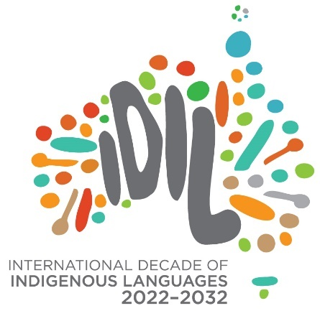

# The International Decade of Indigenous Languages Directions Group Communique March 2023

*“Genocide through linguicide continues”* Vicki Couzens, Directions Group meeting 23 March 2023

The International Decade of Indigenous Languages Directions Group (Directions Group) held its 11th meeting on 23-24 March 2023 on Kaurna Country (Adelaide, South Australia). The Directions Group acknowledges the significance of this week as it followed the first gathering of the Aboriginal and Torres Strait Islander Languages Policy Partnership in lutruwita (Tasmania).

## Directions Group Indigenous Languages Priorities Paper

The Directions Group released its *Indigenous Languages Priorities* paper for consultation within the Aboriginal and Torres Strait Islander languages sector, which is now available for comments [here](https://www.firstlanguages.org.au/news/prioritiespaper). This paper was also presented to the Aboriginal and Torres Strait Islander Languages Policy Partnership. A one-pager was drafted during our meeting to provide a snapshot of the priorities paper and assist communities to engage and discuss with their stakeholders.

## Australia’s Action Plan for the International Decade

The Directions Group and the Australian Government are continuing to work on Australia’s Action Plan for the International Decade 2022-2032 (the Action Plan). The Action Plan will be launched at the *PULiiMA Indigenous Language and Technology Conference* held from 21-25 August 2023 in Larrakia Country (Darwin, Northern Territory).

Building on the outcomes of our previous meeting outlined in the [September Communique](https://www.arts.gov.au/publications/international-decade-indigenous-languages-second-communique)September 2022 Communique, we developed and agreed to high level activities that will bring our themes to life. The five themes are: Stop the Loss; Aboriginal and Torres Strait Islander Communities are Centre; Caring for Country; Intergenerational Knowledge Transfer; and Truth-telling and Celebration.

The five themes will be represented as a native wattle tree in the Action Plan with language, culture, and ancient knowledges as its foundation.

We also identified 10 case studies showcasing best practice partnership approaches that deliver language projects and programs. These case studies represent the real-life delivery of our themes and the types of work we need activities to support.

Any questions about the Directions Group communique can be directed to:

* First Languages Australia, Annalee Pope at [Annalee@firstlanguages.org.au](mailto:Annalee@firstlanguages.org.au)
* Office for the Arts, Tamika Townsend at [IndigenousLanguagesSecretariat@arts.gov.au](mailto:IndigenousLanguagesSecretariat@arts.gov.au)