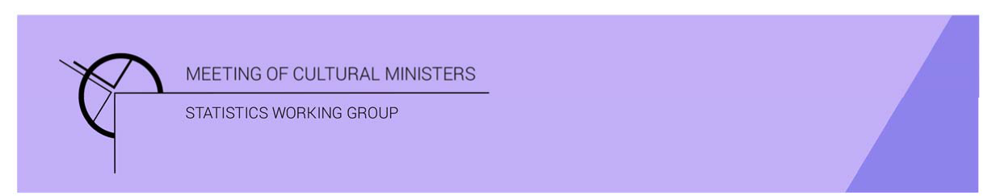

# Cultural Funding by Government—2019–20

## Tasmanian Government

The estimate of expenditure funded by the Tasmanian Government in 2019–20 for cultural activities was **$99.1m**. This represented an increase of 3% or $2.5m from 2017–18[1]. This amount included **$4.3m** of COVID support funding for eligible organisations, businesses, and individuals in creative and cultural industries.[2]

Table 1. Tasmanian Government cultural expenditure, 2016–17 to 2019–20

| 2016–17 | 2017–18 | 2019–20 |
| --- | --- | --- |
| $84.0m | $96.6m ↑15% | $99.1m ↑3% |

* Recurrent expenses accounted for 89% ($88.5m) of funded cultural expenditure.
* Capital expenditure was $10.6m, and the largest contributing category was *Performing arts venues* ($8.9m).
* The estimate of per person funding with COVID support was $184.17, and without was $176.22.

Funds on *Heritage* activities fell 5% (or $3.7m) to $65.4m.

Almost two-thirds (62%) of *Heritage* funding was for *Libraries* ($40.5m). Libraries are mainly funded by the Tasmanian State Government whereas in the other states and the Northern Territory, local governments also contribute significantly to the funding of libraries.

Figure 1. Tasmanian Government heritage expenditure

Funds for *Arts* activities increased 7% (or $1.9m) to $29.4m. The main contributors to this increase were funding for *Multi-arts festivals* ↑$2.3m, *Film and video production and distribution* ↑$1.0m and *Music* ↑$0.9m.

Figure 2. Tasmanian Government arts expenditure, by selected categories

*Performing arts venues* ($9.9m) accounted for one-third (or 34%) of all funded expenditure by the Tasmanian Government on *Arts* activities, due to capital investment. This was followed by *Multi-arts festivals* ($6.7m or 23%).

Other main categories of *Arts* activities funding were:

* *Music*—$3.7m
* *Visual arts and crafts*—$1.8m
* *Film and video production and distribution*—$1.4m.

Total recurrent expenditure rose 10% (or $7.7m) to $88.5m (including $4.3m for COVID support funding).[3]

The largest recurrent expenditure was for *Libraries*, $39.7m, followed by *Art museums* ($10.4m) and *Other museums and cultural heritage* ($10.2m).

Figure 3. Tasmanian Government recurrent cultural expenditure, by selected categories

* The largest recurrent dollar increase was for the category of *Multi-arts festivals* ↑$2.3m between 2017–18 and 2019–20.

1. *Cultural Funding by Government* survey not conducted in 2018–19, as it changed to a biennial collection.
2. COVID support funding included in Total recurrent and Total figures only. COVID funding not reported by category.
3. COVID support funding included in Total recurrent and Total figures only. COVID funding not reported by category.