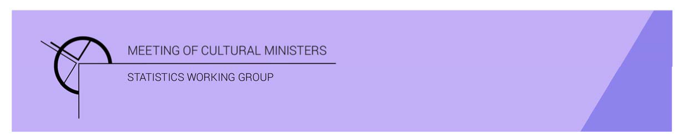

# Cultural Funding by Government—2019–20

## State and territory government

In 2019–20 the estimate of expenditure on cultural activities, funded by state and territory governments, was **$2,716.5m.** This represented a rise of 14% (or $325.9m)[1]. This amount included an additional **$50.1m** of funding allocated to COVID support funding for eligible organisations, businesses, and individuals in creative and cultural industries.[2]

* The estimate of expenditure on cultural activities excluding COVID support funding was **$2,666.4m**, an increase of 12% or $275.8m from 2017–18.

Table 1. State and territory government cultural expenditure, 2016–17 to 2019–20

| 2016–17 | 2017–18 | 2019–20 | 2019–20  *Without COVID support funding* |
| --- | --- | --- | --- |
| $2,041.6m | $2,390.6m ↑17% | $2,716.5m ↑14% | $2,666.4m ↑12% |

* The estimate of per person cultural funding including COVID support funding was $106.28, and without was $104.32

Individual state and territory government's expenditure on cultural activities closely reflected population size. All state and territory governments increased funding between 2017–18 and 2019–20 except South Australia which decreased by 6% or $14.4m, due to the completion of capital works.

Figure 1. State and territory governments total cultural expenditure(a)

1. Care should be taken when comparing expenditure between states and territories due to different administrative arrangements.

The highest percentage increase in funding was for New South Wales and Western Australia (both 27%).

### Heritage

Funds on *Heritage* activities rose 12% (or $158.6m) to $1,458.0m.

The increase was driven by expenditure on all categories including *Art museums* (↑$90.7m), *Other museums and cultural heritage* (↑$31.7m), *Libraries* (↑$23.4m) and *Archives* (↑$12.9m).

The largest categories of *Heritage* expenditure were *Other museums and cultural heritage* with $597.5m, followed by *Libraries* with $484.1m.

The New South Wales Government was the largest contributor to *Other museums and cultural heritage* accounting for $236.2m (40%) of total state and territory government expenditure on this category. Western Australian Government (27%) was the next highest contributor ($162.0m).

The Victorian Government was the largest contributor to *Libraries*, $109.1m or 23% of total state and territory government expenditure on this category.

Figure 2. State and territory government heritage expenditure

### Arts

Funds for *Arts* activities rose 11% (or $117.1m) to $1,208.3m. The main contributors to this movement were *Performing arts venues* (↑$56.0m), and *Film and video production and distribution* (↑$35.6m). Conversely, funding for *Cross-art form* ($31.8m) and *Multi-arts festivals* ($11.3) dropped.

Figure 3. State and territory government arts expenditure, by selected categories

The highest amount of state and territory government *Arts* expenditure was for *Performing arts venues* ($411.9m), with the governments of New South Wales ($153.5m or 37%) and Queensland ($74.2m or 18%) contributing most of the funding in this category.

Other main categories of *Arts* activities funding were:

* *Film and video production and distribution*—$138.1m
* *Arts education*—$136.2m
* *Music*—$77.4m
* *Multi-arts festivals*—$56.0m
* *Visual arts and crafts*—$50.1m.

### Recurrent expenditure

Total recurrent expenditure rose 10% (or $181.4m) to $2,019.1m and accounted for 74% of total funded cultural expenditure. This included $50.1m in COVID support funding.[3]

The largest recurrent expenditure was for *Libraries* with $440.6m.

* The Victorian Government spent the most recurrent dollars on *Libraries* ($102.1m).
* Most state and territory governments (except New South Wales and Northern Territory) spent the largest % of their recurrent expenditure on *Libraries*. Tasmania had the highest with 45%.

Other main categories of recurrent expenditure were:

* *Other museums and cultural heritage*—$363.6m
* *Art museums*—$224.4m
* *Performing arts venues*—$156.1m.

Figure 4. State and territory government recurrent cultural expenditure, by selected categories

The Victorian Government had the highest estimate of recurrent expenditure with $503.8m.

* The New South Wales Government had the highest recurrent expenditure on *Heritage* activities ($277.3m).
* Conversely, the Victorian Government had the highest recurrent expenditure on *Arts* activities ($227.8m).

Figure 5. State and territory governments recurrent cultural expenditure(a), heritage and arts—2019–20

1. Care should be taken when comparing expenditure between states and territories due to different administrative arrangements.

### Capital expenditure

Capital expenditure accounted for 26% ($697.4m) of total state and territory funded cultural spending.

* The largest two categories were *Performing arts venues* ($255.8m) and *Other museums and cultural heritage* ($233.9m).

The New South Wales Government contributed the most capital expenditure for both categories of *Performing arts venues* ($135.8m or 53%)and *Other museums and cultural heritage* ($101.7m or 43%).

Figure 6. State and territory governments capital cultural expenditure(a), heritage and arts—2019–20

1. Care should be taken when comparing expenditure between states and territories due to different administrative arrangements.

The New South Wales Government had the highest capital expenditure on *Heritage* activities ($178.2m) followed by Western Australia ($107.8m) and Queensland ($45.2m).

The New South Wales Government also had the highest estimate for capital expenditure on *Arts* activities ($173.6m), followed by Victoria ($61.5m).

1. *Cultural Funding by Government* survey not conducted in 2018–19, as it changed to a biennial collection.
2. Additional $50.1m in COVID support funding reported: Victoria; $35.2m, South Australia; $7.6m, Tasmania; $4.3m, and ACT Government; $3.1m. Some state and territory governments unable to identify the ‘creative and cultural only’ COVID support funding for 2019–20. Queensland Government reallocated and bought forward $12.5m in funding for COVID support for 2019–20. All state and territory governments likely to report COVID support funding in 2020–21 financial year.
3. Additional COVID support funding included in Total recurrent and Total figures only, and not reported by category.