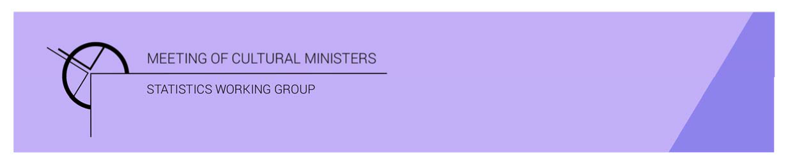

# Cultural Funding by Government—2019–20

## South Australian Government

The estimate of expenditure funded by the South Australian Government in 2019–20 for cultural activities was **$239.3m** representing a decrease of 6% or $14.4m from 2017–18[1]. This amount included **$7.6m** of COVID support funding for eligible organisations, businesses, and individuals in creative and cultural industries.[2]

Table 1. South Australian Government cultural expenditure, 2016–17 to 2019–20

| 2016–17 | 2017–18 | 2019–20 |
| --- | --- | --- |
| $200.5m | $253.7m ↑27% | $239.3m ↓6% |

* Recurrent expenses accounted for 86% ($206.4m) of funded cultural expenditure.
* Capital expenditure was $32.9m, and the largest contributing category was *Performing arts venues* ($28.8m).
* The estimate of per person funding with COVID support was $135.86, and without was $131.56.

Funds on *Heritage* activities rose 5% (or $4.6m) to $91.6m.

This increase was driven by expenditure on *Other museums and cultural heritage* (↑$6.1m), offset by a fall in *Libraries* (↓$1.2m).

The largest categories of *Heritage* expenditure were *Libraries* with $36.5m, followed by *Other museums and cultural heritage* with $35.3m.

Figure 1. South Australian Government heritage expenditure

Funds for *Arts* activities decreased 16% (or $26.5m) to $140.2m. The main contributors to this decrease were *Performing arts venues* ↓$17.9m (due to completion of capital works), *Visual arts and crafts* ↓$3.0m and *Music* ↓$2.6m*.*

Conversely, increases were reported for *Community arts and cultural development* ↑$6.5m and *Arts education* ↑$1.6m.

Figure 2. South Australian Government arts expenditure, by selected categories

*Performing arts venues* ($55.4m), accounted for over one-third (or 39%) of all funded expenditure by the South Australian Government on *Arts* activities.

Other main categories of *Arts* activities funding were:

* *Arts education*—$16.1m
* *Multi-arts festivals*—$12.0m
* *Music*—$10.3m
* *Film and video production and distribution*—$8.6m.

Total recurrent expenditure had a small increase of 1% (or $2.1m) to $206.4m (including $7.6m for COVID support funding).[3]

The largest recurrent expenditure was for *Libraries*, $36.5m, and the largest recurrent dollar increase were for the categories of *Other museums and cultural heritage*, ↑$7.5m and *Community arts and cultural development* ↑$5.7m, between 2017–18 and 2019–20.

Figure 3. South Australian Government recurrent cultural expenditure, by selected categories

1. *Cultural Funding by Government* survey not conducted in 2018–19, as it changed to a biennial collection.
2. COVID support funding included in Total recurrent and Total figures only. COVID funding not reported by category.
3. COVID support funding included in Total recurrent and Total figures only. COVID funding not reported by category.