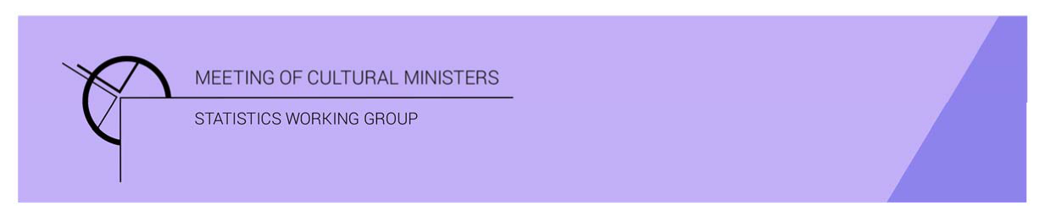

# Cultural Funding by Government — 2017–18

## South Australian Government

The estimate of expenditure funded by the South Australian Government in 2017–18 for cultural activities was **$253.7m**. This represented an increase of 27% or $53.2m from 2016–17.

Table — South Australian Government cultural expenditure, 2015–16 to 2017–18

| 2015–16 | 2016–17 | 2017–18 |
| --- | --- | --- |
| $184.2m | $200.5m ↑ 9% | $253.7m ↑ 27% |

* Recurrent expenses accounted for 81% ($204.3m) of funded cultural expenditure.
* Capital expenditure was $49.4m, and the largest two categories were *Performing art venues* ($43.4m) and *Other museums and cultural heritage* ($2.2m).
* The estimate of per person cultural funding was $146.78.

Funding for *Heritage* activities remained steady at $87.0m compared with $86.6m in 2016–17.

Expenditure on *Libraries* rose by $1.4m, offset by a fall in *Art museums* (↓$1.0m).

The largest categories of *Heritage* expenditure were *Libraries* with $37.7m followed by *Other museums and cultural heritage* with $29.2m.

Figure 1. South Australian Government heritage expenditure

Figure 1. South Australian Government heritage expenditure.

A column graph compares expenditure across the heritage categories of Art museums, Other museums and cultural heritage, Libraries and Archives between the financial years of 2015-16, 2016-17 and 2017-18 for South Australian Government.

Funds for *Arts* activities rose 46% (or $52.8m) to $166.7m.

The main contributor to this increase was *Performing art venues* ↑$40.6m, due primarily to capital investment. Increases were also reported for *Music* ↑$2.4m and *Multi-arts festivals* ↑$1.9m.

Figure 2. South Australian Government arts expenditure, by selected categories

Figure 2. South Australian Government arts expenditure, by selected categories.

A column graph compares expenditure across selected arts categories of Music, Performing arts venues, Cross-art form, Film and video production and distribution, Arts education, Multi-arts festivals and Arts administration between the financial years of 2015-16, 2016-17 and 2017-18 for South Australian Government.

*Performing arts venues* ($73.3m), accounted for over one-third (or 44%) of all funded expenditure by the South Australian Government on Arts activities.

Other main categories of *Arts* activities funding were:

* *Arts education*—$14.5m
* *Multi-arts festivals*—$13.3m
* *Music*—$12.9m
* *Film and video production and distribution*—$10.4m
* *Cross-art form*—$9.8m.

Recurrent expenditure rose 11% (or $19.6m) to $204.3m.

The largest recurrent expenditure was for *Libraries*, $36.0m, followed by *Performing arts venues* ($29.9m).

Figure 3. South Australian Government recurrent cultural expenditure, by selected categories

Figure 3. South Australian Government recurrent cultural expenditure, by selected categories.

A bar chart compares recurrent expenditure across selected  categories of Art museums, Other museums and cultural heritage, Libraries, Music, Performing arts venues, Cross-art form, Film and video production and distribution, Arts education and Multi-arts festivals between the financial years of 2015-16, 2016-17 and 2017-18 for South Australian Government.

* The largest recurrent dollar increase was for the category of *Performing arts venues*, ↑$3.9m between 2016–17 and 2017–18.