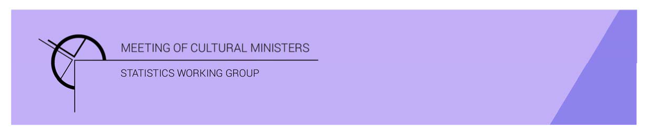

# Cultural Funding by Government—2019–20

## Queensland Government

The estimate of expenditure funded by the Queensland Government in 2019–20 for cultural activities was **$450.2m[1]**. This represented an increase of 8% or $34.4m from 2017–18[2].

Table 1. Queensland Government cultural expenditure, 2016–17 to 2019–20

| 2016–17 | 2017–18 | 2019–20 |
| --- | --- | --- |
| $367.1m | $415.8m ↑13% | $450.2 ↑8% |

* Recurrent expenses accounted for 83% ($373.9m) of funded cultural expenditure.
* Capital expenditure was $76.3m, and the largest two categories were *Performing art venues* ($31.0m) and *Other museums and cultural heritage* ($26.8m).
* The estimate of per person cultural funding was $87.64.

Funds on *Heritage* activities rose 5% (or $11.8m) to $253.1m.

This increase was driven by expenditure on the categories of *Art museums* (↑$5.9m) and *Other museums and cultural heritage* (↑$4.8m). Increases were offset by a fall in *Libraries* (↓$2.3m).

The largest categories of *Heritage* expenditure were *Libraries* $88.5m, followed by *Other museums and cultural heritage* with $80.5m.

Figure 1. Queensland Government heritage expenditure

Funds for *Arts* activities rose 13% (or $22.6m) to $197.1m.

Three main contributors to this movement were *Performing arts venues* ↑$26.9m, *Arts education* ↑$6.3m and *Community arts and cultural development* ↑$2.2m. Conversely, funding for both *Music* and *Radio and television services* dropped $3.4m.

Figure 2. Queensland Government arts expenditure, by selected categories

*Performing arts venues* ($74.2m), accounted for over one-third (or 38%) of all funded expenditure by the Queensland Government on *Arts* activities.

Other main categories of *Arts* activities funding were:

* *Arts education*—$41.5m
* *Film and video production and distribution*—$19.3m
* *Music*—$8.5m
* *Multi-arts festivals*—$8.4m
* *Theatre*—$6.7m.

Recurrent expenditure rose 2% (or $7.4m) to $373.9m.

The largest recurrent expenditure was for *Libraries* $79.5m, followed by *Art museums* ($56.5m) and *Other museums and cultural heritage* ($53.6m).

Figure 3. Queensland Government recurrent cultural expenditure, by selected categories

* The largest recurrent dollar increase was for the category of *Performing arts venues*, ↑$10.3m between 2017–18 and 2019–20.

1. In 2019–20, the Queensland Government reallocated and bought forward $12.5m in funding to support creative and cultural industries in direct response to the impact of COVID, with this expenditure reported across categories.
2. *Cultural Funding by Government* survey not conducted in 2018–19, as it changed to a biennial collection.