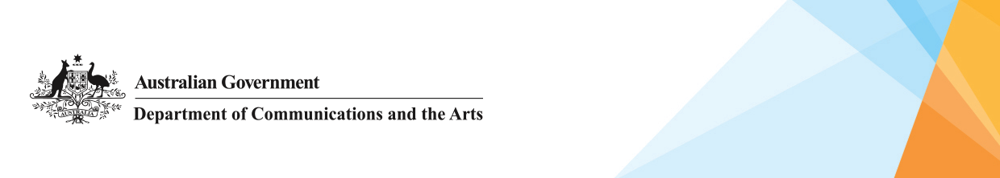

Protect, preserve and celebrate Indigenous languages
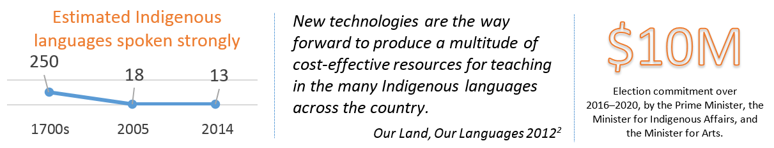
¹ Figures represent languages considered strong, taken from the National Indigenous Languages Surveys (2005 and 2014)
² Australian Government, House of Representatives, Our Land, Our Languages, 2012

The Australian Government is resolute in its commitment to close the gap in Indigenous life expectancy, child mortality, education and employment. In this pursuit we must continue to celebrate and be proud of the rich diversity of Indigenous experience and history.
We know Australia’s Indigenous languages play an integral role in cultural maintenance for our Aboriginal and Torres Strait Islander communities. We celebrate the diversity of Indigenous languages and the contribution they make to a richer community for all Australians.
We recognise that resources to capture, record and store language material can assist with language preservation. Language teaching capacity and learning pathways are also critical elements for language revival and maintenance.

Existing support
This $10 million commitment to language initiatives is in addition to the $20 million in annual support provided through the ongoing Indigenous Languages and Arts (ILA) program for arts and languages projects and organisations. The two programs complement each other and are guided by the Indigenous Languages and Arts program Guidelines.
The ILA program is consistent with, and complementary to, the Government’s broader support for Indigenous cultural maintenance and wellbeing under the Indigenous Advancement Strategy and Closing the Gap.

The $10 million commitment
Technology is already playing a vital part in language survival and revival, however more can be done to capitalise on the opportunities provided by digital innovation.
This is why the Government has committed an additional $10 million to protect, preserve and celebrate Indigenous languages over four years from 2016–2020.
With this in mind, the election commitment will focus on:
- Working in partnership with Indigenous communities to identify and facilitate digital opportunities.
- Support for innovative digital solutions to capture and teach language.
- Identifying opportunities to develop career pathways for Indigenous language workers and linguists.
- Encouraging collaborative approaches to building the digital skills and capabilities of communities.
To support and guide this funding, the Department of Communications and the Arts will engage with those working to maintain and revive their languages. We will also bring these people together with a wider variety of stakeholders to facilitate partnerships informed by community experience.

For more information
- Visit www.arts.gov.au.
- Email ila@arts.gov.au.
- Call 1800 006 992.

