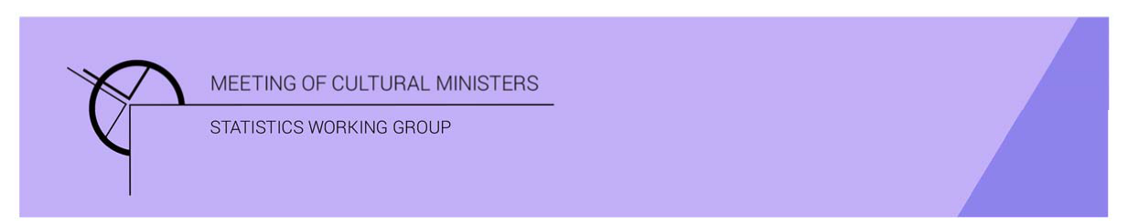

# Cultural Funding by Government—2019–20

## Overview

In 2019–20, the estimate of total expenditure on cultural activities, funded by the three tiers of government, was **$11,582.7m**. This amount included **$4,322.3m** of COVID support funding for eligible organisations, businesses, and individuals.

The Australian Government COVID support funding was $4,272.1m ($3,065.3m *JobKeeper* payments, $1,168.4m *Boosting Cash Flow for Employers*, and $38.4m *Arts portfolio grants*). State and territory government COVID support funding was $50.1m.

The **$11,582.7m in** funding for cultural activities from the three tiers of government comprised the following:

* $7,025.7m (61% of total) from the Australian Government
* $2,716.5m (24%) from state and territory governments
* $1,840.5m (16%) from local governments.

Figure 1. Cultural expenditure, by level of government

Total expenditure rose 69% (or $4,719.7m) from 2017–18[1]. Expenditure increased across all levels of government.

Table 1. Total Government cultural expenditure, 2016–17 to 2019–20

| 2016–17 | 2017–18 | 2019–20 | 2019–20  *Without COVID support funding* |
| --- | --- | --- | --- |
| $6,098.5m | $6,863.0m ↑13% | $11,582.7m ↑69% | $7,260.4 ↑6% |

Total recurrent expenditure rose 83% (or $4,703.3m) to $10,342.1m. This included $4,322.3mof COVID support funding.[2]

* Recurrent expenses accounted for 89% of total funded cultural expenditure.
* Recurrent expenditure by the Australian Government was $6,764.1m, the highest amount of the three levels of government (65%of total recurrent expenditure).

Capital expenditure by all levels of government was $1,240.6m in 2019–20, an increase of 1% (or $16.4m) from 2017–18.

* Most capital expenditure was funded by State and territory government with $697.4m (56% of total capital expenditure).

Figure 2. Cultural expenditure, recurrent and capital, by level of government—2019–20

The five categories with the highest expenditure funded by the Australian Government in 2019–20 were:

1. *Radio and television services*—$1,384.3m
2. *Other museums and cultural heritage*—$452.8m
3. *Archives*—$192.0m
4. *Film and video production and distribution*—$119.5m
5. *Libraries*—$95.8m.

The five categories with the highest expenditure by State and territory government in 2019–20 were:

1. *Other museums and cultural heritage*—$597.5m
2. *Libraries*—$484.1m
3. *Performing arts venues*—$411.9m
4. *Art museums*—$307.1m
5. *Film and video production and distribution* —$138.1m.

The estimate of per person cultural funding by the three tiers of government including COVID support funding was $453.16. This comprised:

* Australian Government—$274.87
* State and territory government—$106.28
* Local government—$72.01.

The estimate of per person cultural funding by the three tiers of government excluding COVID support funding was $284.05. This comprised:

* Australian Government—$107.73
* State and territory government—$104.32
* Local government—$72.01.

Table 2. Per Person cultural expenditure, by level of government

|  | Australian Government | State and territory government | **Local government** |
| --- | --- | --- | --- |
| Heritage | $32.65 | $57.04 | NA |
| Arts | $75.08 | $47.27 | NA |
| Total (*including* COVID support funding) | $274.87 | $106.28 | $72.01 |
| Total (*excluding* COVID support funding) | $107.73 | $104.32 | $72.01 |

1. *Cultural Funding by Government* survey not conducted in 2018–19, as it changed to a biennial collection.
2. COVID support funding included in Total recurrent and Total figures only. COVID funding not reported by category.