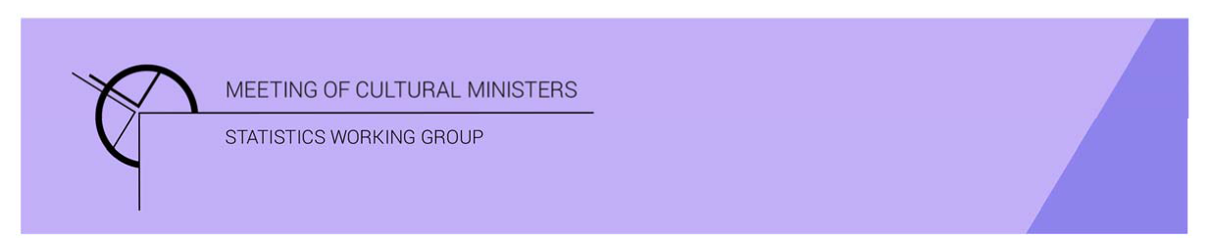

# Cultural Funding by Government—2019–20

## Northern Territory Government

The estimate of expenditure funded by the Northern Territory Government in 2019–20 for cultural activities was **$76.0m**. This represented an increase of 2% or $1.8m from 2017–18[1].

Table. 1 Northern Territory Government cultural expenditure, 2016 –17 to 2019 –20

| 2016–17 | 2017–18 | 2019–20 |
| --- | --- | --- |
| $60.0m | $74.2m ↑24% | $76.0m ↑2% |

* Recurrent expenses accounted for 88% ($67.0m) of funded cultural expenditure.
* Capital expenditure was $9.0m, and the largest category was *Art museums* ($7.2m).
* The estimate of per person cultural funding was $309.80.

Funds on *Heritage* activities decreased 11% (or $4.8m) to $37.1m.

This decrease was driven by lower expenditure on *Art museums* (↓$2.9m) and *Other museums and cultural heritage* (↓$1.5m).

The largest categories of *Heritage* expenditure were *Art museums* with $19.7m followed by *Libraries* with $10.5m. Expenditure on *Art museums* was over half (53%) the *Heritage* expenditure by the Northern Territory Government.

Figure 1. Northern Territory Government heritage expenditure

Funds for *Arts* activities rose 20% (or $6.6m) to $38.9m.

Two main contributors to this movement were *Visual arts and crafts* ↑$4.5m, and *Film and video production and distribution* ↑$1.8m.

The category with the largest fall was *Community arts and cultural development* ↓$2.1m.

Figure 2. Northern Territory Government arts expenditure, by selected categories

The main categories of *Arts* activities funding were:

* *Visual arts and crafts*—$7.2m
* *Multi-arts festivals*—$5.0m
* *Film and video production and distribution*—$3.3m
* *Performing arts venues*—$3.2m
* *Arts education*—$3.1m.

Recurrent expenditure rose 2% (or $1.3m) to $67.0m.

The largest recurrent expenditure was for *Art museums*, $12.5m, and the largest dollar increase was for the category of *Visual arts and crafts* ↑$4.4m between 2017–18 and 2019–20.

Figure 3. Northern Territory Government recurrent cultural expenditure, by selected categories

1. *Cultural Funding by Government* survey not conducted in 2018–19, as it changed to a biennial collection.