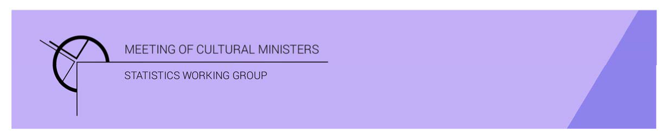

# Cultural Funding by Government — 2017–18

## Northern Territory Government

The estimate of expenditure funded by the Northern Territory Government in 2017–18 for cultural activities was **$74.2m**. This represented an increase of 24% or $14.2m from 2016–17.

Table 1—Northern Territory Government cultural expenditure, 2015–16 to 2017–18

| 2015–16 | 2016–17 | 2017–18 |
| --- | --- | --- |
| $53.0m | $60.0m ↑ 13% | $74.2m ↑ 24% |

* Recurrent expenses accounted for 89% ($65.7m) of funded cultural expenditure.
* Capital expenditure was $8.5m, and the largest two categories were *Art museums* ($6.8m) and *Performing art venues* ($1.1m).
* The estimate of per person cultural funding was $300.46.

Funds on *Heritage* activities rose 23% (or $7.9m) to $41.9m.

This increase was driven by expenditure on *Art Museums* (↑$8.1m) but offset by a fall in *Libraries* (↓$0.9m).

The largest categories of *Heritage* expenditure were *Art Museums* with $22.6m followed by *Libraries* with $10.3m. Expenditure on *Art Museums* was over half (54%) the *Heritage* expenditure by the Northern Territory Government.

Figure 1. Northern Territory Government heritage expenditure

Figure 1. Northern Territory Government heritage expenditure.

A column graph compares expenditure across the heritage categories of Art museums, Other museums and cultural heritage, Libraries and Archives between the financial years of 2015-16, 2016-17 and 2017-18 for Northern Territory Government.

Funds for *Arts* activities rose 24% (or $6.3m) to $32.3m.

Increased expenditure was reported across several categories between 2016–17 and 2017–18. Two main contributors to this movement were *Music* ↑$2.3m, and *Community arts and cultural development* ↑$1.2m.

The category with the largest fall was *Cross-art form* ↓$1.8m.

Figure 2. Northern Territory Government arts expenditure, by selected categories

Figure 2. Northern Territory Government arts expenditure, by selected categories.

A column graph compares expenditure across selected arts categories of Music, Performing arts venues, Visual arts and crafts, Arts education, Community arts and cultural development, Multi-arts festivals and Arts administration between the financial years of 2015-16, 2016-17 and 2017-18 for Northern Territory Government.

The main categories of *Arts* activities funding were:

* *Multi-arts festivals*—$4.3m
* *Performing arts venues*—$3.6m
* *Arts education*—$3.2m
* *Music*—$3.1m
* *Community arts and cultural development*—$3.0m.

Recurrent expenditure rose 15% (or $8.5m) to $65.7m.

The largest recurrent expenditure was for *Art Museums*, $15.7m, and the largest dollar increase was also for the category of *Art Museums* ↑$3.5m between 2016–17 and 2017–18.

Figure 3. Northern Territory Government recurrent cultural expenditure, by selected categories

Figure 3. Northern Territory Government recurrent cultural expenditure, by selected categories.


A bar chart compares recurrent expenditure across selected  categories of Art museums, Other museums and cultural heritage, Libraries, Music, Visual arts and crafts, Arts education, Community arts and cultural development, Multi-arts festivals and Arts administration between the financial years of 2015-16, 2016-17 and 2017-18 for Northern Territory Government.