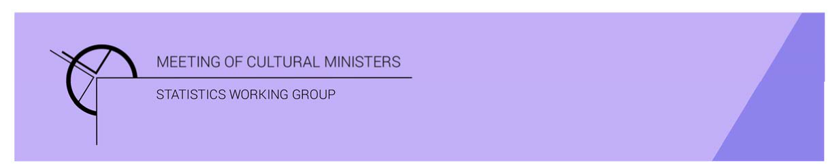

# Cultural Funding by Government — 2017–18

## New South Wales Government

The estimate of expenditure funded by the New South Wales Government in 2017–18 for cultural activities was **$627.0m**. This represented an increase of 31% or $148.3m from 2016–17.

Table 1—New South Wales Government cultural expenditure, 2015–16 to 2017–18

| 2015–16 | 2016–17 | 2017–18 |
| --- | --- | --- |
| $475.5m | $478.7m ↑ 1% | $627.0m ↑ 31% |

* Recurrent expenses accounted for 61% ($384.6m) of funded cultural expenditure.
* Capital expenditure was $242.5m, and the largest two categories were *Performing art venues* ($131.1m) and *Other museums and cultural heritage* ($78.5m).
* The estimate of per person cultural funding was $79.15.

Funds on *Heritage* activities rose 23% (or $63.2m) to $343.3m.

This increase was driven by expenditure on the categories of *Other museums and cultural heritage* (↑$59.7m) and *Art Museums* (↑$4.5m).

Just under two-thirds (62%) of *Heritage* funds were spent on *Other museums and cultural heritage* ($212.1m)with an additional 26% spent on *Libraries* ($88.4m).

Figure 1. New South Wales Government heritage expenditure

Figure 1. New South Wales Government heritage expenditure.

A column graph compares expenditure across the heritage categories of Art museums, Other museums and cultural heritage, Libraries and Archives between the financial years of 2015-16, 2016-17 and 2017-18 for New South Wales Government.

Funds for *Arts* activities rose 43% (or $85.1m) to $283.7m.

Three main contributors to this movement were *Performing art venues* ↑$75.5m, *Music* ↑$9.6m and *Arts education* ↑$7.6m. Conversely, funding for *Music theatre and opera* dropped by $8.1m.

Figure 2. New South Wales Government arts expenditure, by selected categories

Figure 2. New South Wales Government arts expenditure, by selected categories.

A column graph compares expenditure across selected arts categories of Music, Performing arts venues, Cross-art form, Visual arts and crafts, Film and video production and distribution, Arts education and Arts administration between the financial years of 2015-16, 2016-17 and 2017-18 for New South Wales Government.

Just over half (51%)of all funded expenditure by the New South Wales Government on *Arts* activities was spent on *Performing arts venues* ($144.3), the majority for capital projects.

Other main categories of *Arts* activities funding were:

* *Visual arts and crafts*—$17.5m
* *Cross-art form*—$17.3m
* *Music*—$16.3m
* *Film and video production and distribution*—$14.7m.

Recurrent expenditure dropped 1% (or $4.1m) to $384.6m.

Table 2 — New South Wales Government recurrent cultural expenditure, 2015–16 to 2017–18

| 2015–16 | 2016–17 | 2017–18 |
| --- | --- | --- |
| $356.8m | $388.7m ↑ 9% | $384.6m ↓ 1% |

The largest recurrent expenditure was for *Other museums and cultural heritage*, $133.7m, followed by *Libraries* ($71.8m).

Figure 3. New South Wales Government recurrent cultural expenditure, by selected categories

Figure 3. New South Wales Government recurrent cultural expenditure, by selected categories.

A bar chart compares recurrent expenditure across selected  categories of Art museums, Other museums and cultural heritage, Libraries, Music, Performing arts venues, Cross-art form, Visual arts & crafts, Film and video production and distribution, and Arts administration between the financial years of 2015-16, 2016-17 and 2017-18 for New South Wales Government.