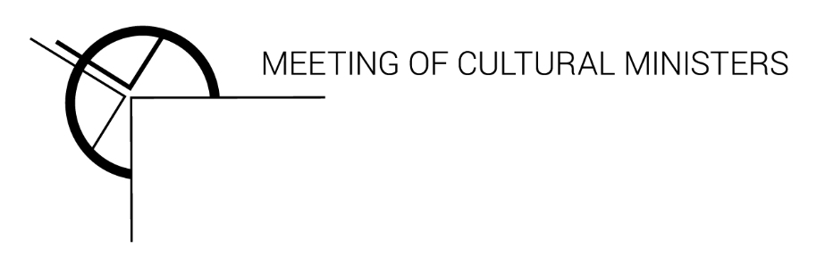

# Communiqué

A meeting of Arts and Cultural Ministers was held today, Friday 13 November 2020.

## Attendees

Australian Government: The Hon Paul Fletcher MP, Minister for Communications, Cyber Safety and the Arts

New South Wales: The Hon Don Harwin MLC, Leader of the Government in the Legislative Council, Special Minister of State, Minister for the Public Service and Employee Relations, Aboriginal Affairs, and the Arts, Vice-President of the Executive Council

Australian Capital Territory: Ms Tara Cheyne MLA, Assistant Minister for Economic Development; Minister for the Arts; Minister for Business and Better Regulation; Minister for Human Rights; Minister for Multicultural Affairs

Northern Territory: The Hon Chanston Paech MLA, Minister for Local Government; Minister for Central Australian Economic Reconstruction; Minister for Remote Housing and Town Camps; Minister for Indigenous Essential Services; Minister for Arts, Culture and Heritage

South Australia: The Hon Steven Marshall MP, Premier of South Australia; Responsible for Aboriginal Affairs and Reconciliation; Defence and Space Industries; The Arts; Tourism; Veterans' Affairs; and Multicultural Affairs

Queensland: The Hon Leeanne Enoch MP, Minister for Communities and Housing, Minister for Digital Economy and Minister for the Arts

Tasmania: The Hon Elise Archer MP, Attorney-General; Minister for Justice; Minister for Corrections; Minister for Building and Construction; Minister for the Arts; Minister for Heritage

Victoria: Mr Danny Pearson MP, Assistant Treasurer; Minister for Regulatory Reform; Minister for Government Services; Minister for Creative Industries

Western Australia: The Hon David Templeman MLA, Minister for Local Government; Minister for Heritage; Minister for Culture and The Arts

## Observers

Mr Adrian Collette AM, Chief Executive Officer, Australia Council for the Arts

Mr Bethune Carmichael, Policy Advisor, Australian Local Government Association

## Apologies

New Zealand (International Member): The Hon. Carmel Sepuloni, Minister for Social Development and Employment; Minister for ACC; Minister for Arts, Culture and Heritage; Minister for Disability Issues

## Communiqué

**Arts and the Australian economy**

Australia’s Arts Ministers today met and reaffirmed the vital importance of arts and culture to the Australian economy as a creator of jobs, and highlighted the importance of arts and cultural activities to the physical and mental health of the nation.

**COVID-19**

Australian Bureau of Statistics data showed in the Au*stralian National Accounts: National Income, Expenditure and Product* that arts and recreation services were the second most heavily impacted industry sector at -24.5% from June 2019 to June 2020.

Governments across Australia have invested significant amounts to ensure the viability of the arts and cultural sector which is so heavily impacted by COVID-19. This investment was also critical to securing the ongoing development of future works, ensuring communities have opportunities to enjoy social outlets, especially those experiencing lockdowns.

There is more work to be done.

The next phase identified by Arts Ministers is the re-opening of theatres and performance spaces in accordance with jurisdictional health advice. Opening our arts and cultural venues to the maximum possible COVID-Safe capacity, with an aspiration to return to 100% as soon as possible, will boost the arts and cultural sector, and will benefit the small businesses and industries that support this activity, including tourism, hospitality and transport.

**Future of the Meeting of Cultural Ministers**

This meeting of Arts Ministers was the last formal Meeting of Cultural Ministers.

The decision announced by the National Cabinet on 23 October is to disband the Australian Arts Ministers’ Forum – the Meeting of Cultural Ministers. The Ministers noted that the COVID-19 pandemic has demonstrated there is much to be gained from collaboration and the sharing of information and resources among Governments, whilst recognising that in many cases we share funding responsibilities.

Arts and culture define who we are; they tell Australian stories about our diverse communities and our land. Artists, creatives, and cultural workers play an essential role in ensuring these stories are told.

The arts is a key driver of the Australian economy. The Bureau of Communications, Arts and Regional Research reported that cultural and creative activity generated $115.2 billion to Australia’s economy in 2017/18 - 6.4% of Australian GDP.

The Ministers resolved to keep meeting regularly into the future to further progress important items including:

* First Nations arts and culture
* Culturally and linguistically diverse arts and culture
* Arts and disability
* Children and young people’s arts and culture
* Digital Cultural Strategy
* Cultural research and data collections

Ministers committed to officials forming a working group to provide practical recommendations on continuing cooperation mechanisms in the interests of advancing the arts sector across Australia.

## Media contacts

Media Adviser: Duncan McNab, 0424 282 091

## Secretariat

Telephone: (02) 8289 6531

Email: MCMSecretariat@create.nsw.gov.au