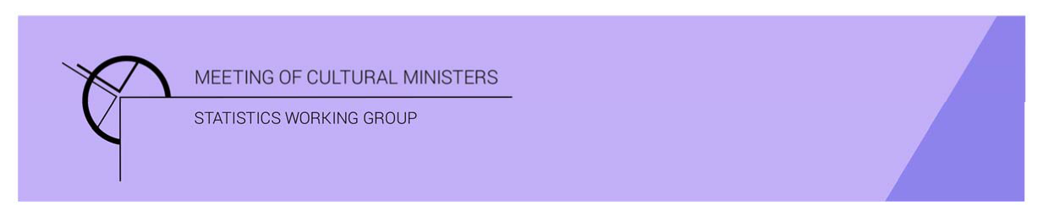

# Cultural Funding by Government — 2017–18

## Local government

The estimate of expenditure funded by Local government in 2017–18 for cultural activities was **$1,797.5m**. This represented just over one quarter (26%) of the total government funded expenditure on cultural activities.

Table 1—Local government cultural expenditure, 2015–16 to 2017–18

| 2015–16 | 2016–17 | 2017–18 |
| --- | --- | --- |
| $1,578.3m | $1,673.2m ↑ 6% | $1,797.5m ↑7 % |

* Local government expenditure for cultural activities rose by 7% (or $124.3m) between 2016–17 and 2017–18.

Expenditure on cultural activities generally reflected the size of the population, with the highly populated states spending more funds on cultural activities (New South Wales—$613.8m, Victoria—$490.6m and Queensland—$323.5m).

Figure 1. Local government cultural expenditure, by state and territory(a)(b)

1. Local government cultural expenditure, by state and territory

A column graph compares cultural expenditure across Australian states and Northern Territory between the financial years of 2015-16, 2016-17 and 2017-18 for Local government.

Australian Capital Territory excluded from the graph as this territory does not have local governments.

1. Care should be taken when comparing expenditure between states and territories due to different administrative arrangements and responsibilities.
2. Australian Capital Territory does not have local governments.

Recurrent expenses rose 7% (or $103.6m) to $1,493.5m.

* Recurrent expenses accounted for 83% of total Local government funded expenditure on cultural activities.
* New South Wales had the largest amount of recurrent expenditure at $515.6m, followed by Victoria ($392.5m) and Queensland ($252.4m).

Total Local government capital expenditure was $304.1m.

* New South Wales and Victoria spent the largest amounts of capital ($98.2m and $98.1m respectively).

Figure 2. Local government cultural expenditure, recurrent and capital, by state and territory(a)(b)—2017–18

Figure 2. Local government cultural expenditure, recurrent and capital, by state and territory—2017–18.

A column graph displays recurrent and capital cultural expenditure across Australian states and Northern Territory for Local government.

Australian Capital Territory excluded from the graph as this territory does not have local governments.

1. Care should be taken when comparing expenditure between states and territories due to different administrative arrangements and responsibilities.
2. Australian Capital Territory does not have local governments.

The estimate of total Local government per person cultural funding was $72.55.

Figure 3. Local government cultural expenditure per person, by state and territory(a)(b)—2017–18

Figure 3. Local government cultural expenditure per person, by state and territory—2017–18

Per Person dollar cultural funding by Australian state and Northern territory.

New South Wales - $77.47;
Victoria - $76.81;
Queensland - $65.19;
South Australia - $99.94;
Western Australia - $67.28;
Tasmania - $38.28;
Northern Territory - $12.46
Total Local government - $72.55

Australian Capital Territory excluded from the graph as this territory does not have local governments. However, included in Total Local government figure.


1. Care should be taken when comparing expenditure between states and territories due to different administrative arrangements and responsibilities.
2. Australian Capital Territory does not have local governments.

* South Australia had the highest per person expenditure of $99.94 followed by New South Wales ($77.47) and Victoria ($76.81).