# Australia and Singapore cultural leaders commit to more partnerships

1. The Arts and Culture Ministers of Australia and Singapore strongly support the development of collaborative works and exchange of knowledge through events and festivals in both countries.

2 Speaking at the Australia-Singapore Cultural Leaders’ Forum,   
Senator the Hon Mitch Fifield (Minister for the Arts, Australia) and Minister Grace Fu (Minister for Culture, Community and Youth, Singapore) affirmed both governments’ intentions to build upon the already substantial cultural links which exist between the nations.

3 The Forum was initiated by the Australia–Singapore Arts Group (ASAG) to provide opportunities to develop relationships and collaborative projects. The ASAG provides advice to each government on strengthening arts and cultural engagement. The ASAG is underpinned by the *Memorandum Understanding on Cooperation in the Field of Arts and Culture* signed by Singapore and Australia in 2015 to signal their vision for stronger cultural cooperation.

4. Adelaide Festival Centre and the South Australian Museum hosted the two-day Forum, bringing together more than 150 culture sector leaders from across Australia and Singapore. The leaders came from diverse fields – museums, galleries, arts festivals, performing arts groups and educational institutions – to network, share best practices and identify opportunities for future collaboration. The topics covered in the panel and roundtable discussions included cultural policy, the power of creative cities, the potential for cultural collaborations, as well as youth and education in the arts.

5 Minister Fu said, “The arts and culture are a key area of focus under the Comprehensive Strategic Partnership, in recognition of their importance to the individual and to nation building. They allow us to connect to our roots and identity, and to communicate our stories to future generations. Arts and culture also bring diverse communities together and foster cross-cultural understanding across nations. With people-to-people exchanges being a key part of Singapore-Australia cultural relations, political support and the work of the Australia-Singapore Arts Group play a meaningful role in strengthening the connections between our two nations.”

6 Minister Fifield said, “The creative economy is a huge force. The arts in the Asia Pacific region make an economic contribution of more than $740 billion, and there are economic opportunities for both our countries through closer collaboration. Arts and cultural exchanges also provide opportunities for artists to develop their skills and share their work with new audiences, and to build mutual cultural understanding. This provides the foundations for enduring relationships and security in the region.”

7 Both Ministers gave keynote addresses on the first day of the Forum, presenting possibilities and setting the scene for in-depth conversations between the cultural leaders. The co-chairs of the Australia-Singapore Arts Group, Mrs Rosa Daniel and Dr Mathew Trinca, welcomed the Forum’s particular focus on the role of arts and culture in creating liveable cities.

8 Mrs Rosa Daniel, Deputy Secretary (Culture), Ministry of Culture, Community and Youth, and CEO of the National Arts Council Singapore said, “Many interesting ideas were raised during the Cultural Leaders’ Forum. We reflected on how we can take them forward together, build up our capabilities, and co-create works that can be shared within both countries as well as in other international markets. I look forward to many exciting years of collaboration ahead.”

9 Dr Mathew Trinca, Director, National Museum of Australia, said, “This historic meeting between Australian and Singaporean arts leaders and key ministers has confirmed support for elevating the cultural relationships between our nations. This partnership and cultural collaboration present us with an unprecedented opportunity to share expertise, ideas and ambitions. In the meantime, both countries will work together on some of the key recommendations of the Forum. These include the creation of distinctive and liveable cities and the development of technical and administrative capabilities. By sharing knowledge and expertise, the arts sectors in both countries can benefit enormously.”

10 The ASAG is proposing to meet again in Singapore next year, and has urged the cultural leaders at the Forum in Adelaide to communicate and report on their progress in further developing arts and cultural cooperation between our two countries.

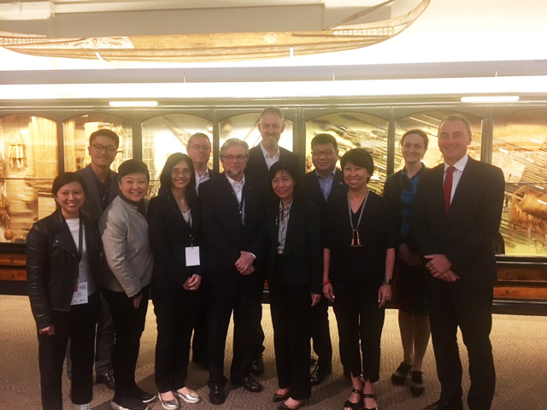

Cultural sector representatives from Singapore and Australia in Adelaide.

*(****First row, l-r****: Ms Yvonne Tham, Ms Angelita Teo, Ms Chang Hwee Nee,   
Mr Douglas Gautier AM, Mrs Rosa Daniel, Ms Chong Siak Ching, Dr Mathew Trinca.* ***Second row, l-r****: Mr Paul Tan, Mr Bruce Gosper, Mr Tony Grybowski,   
Mr Kwok Fook Seng, Ms Claire Spencer)*