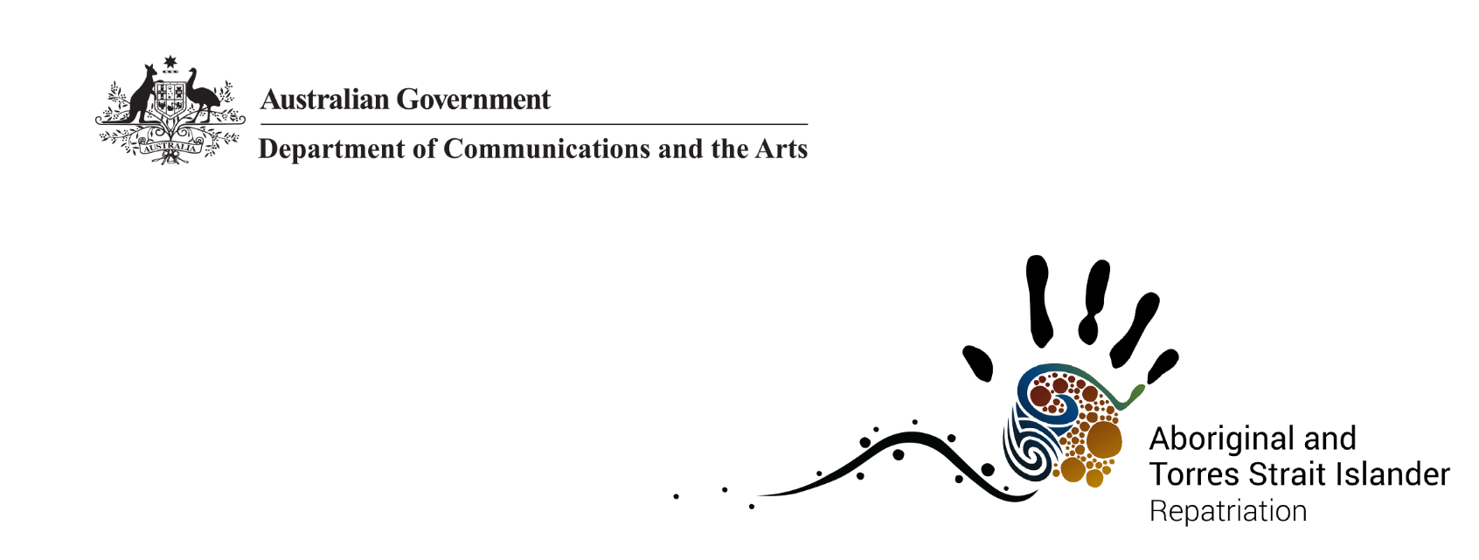

Indigenous Repatriation—International
For more than 150 years, Australian Indigenous ancestral remains were removed by anthropologists, medical officers, anatomists, ethnologists and pastoralists and were taken to museums, universities and private collections in Australia and overseas for ‘scientific’ research linked to explaining human biological differences.
The Australian Government supports the unconditional return of Australian Indigenous ancestral remains through the Department of Communications and the Arts (the department).

About international repatriation
The government has provided support to Australian Indigenous communities for over 30 years to return their ancestors back to their communities of origin.
The department seeks the voluntary and unconditional return of ancestral remains from overseas institutions and private collections. This requires the collaborative efforts of the department; Australian Indigenous communities; international collecting institutions and private holders; other Australian Government departments, including overseas embassy staff; foreign governments; state and territory governments; and Australian and international experts.

Significance of Indigenous repatriation
The government acknowledges Australian Indigenous peoples as the rightful custodians of ancestral remains. Returning ancestors back to Country helps to promote healing, justice and reconciliation for Australian Indigenous peoples. Where communities are known, they are closely involved in the repatriation process. When ancestral remains cannot be identified to community, it is the view of Australian Indigenous peoples that the ancestral remains are returned to Australia to be cared for and brought closer to home.

Number of returned ancestors
The Australian Government has supported the repatriation of Australian Indigenous ancestral remains from overseas for over 30 years across 9 Countries. More than 1600 ancestral remains have been returned to Australia. (As at 28 November 2019.)

Hear from those involved
“Bringing her home, touches on our shared pain and our untold histories. For us, it is important that the past is set right for her and our ancestors.”
Lama Lama People of Yintjingga, Queensland
“We all feel quite sad about our ancestor being taken, but want to ensure her repatriation encourages others to return ancestors to traditional custodians here in Australia in the future.”
Tahn Donovan, Wardandi, Western Australia
“I am happy because I am taking them home, and this feeling I have is coming from their spirit. As we travel home with them I will have the home song going in my mind, I will be singing them home.”
Major Sumner, Ngarrindjeri Elder, South Australia

Find out more
To find out more please call 1800 006 992 or email repatriation@arts.gov.au.
More information is available at www.arts.gov.au/repatriation.

