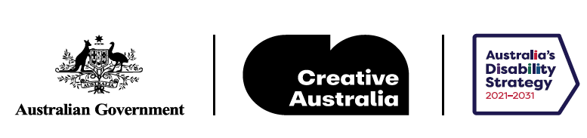

# EQUITY

# The Arts and Disability Associated Plan

Easy Read Version

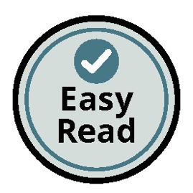

An initiative under Australia’s Cultural Policy, *Revive*

## How to use this Plan

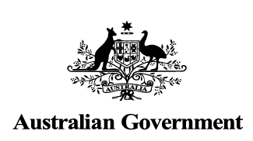

The **Australian Government** wrote this Plan.

When you see the word ‘we’, it means the Australian Government.

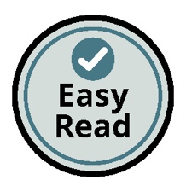

We wrote this Plan so it is easy to read.

We use pictures to explain some ideas.

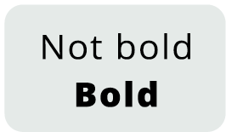

We have written some words in **bold**.

This means the letters are thicker and darker.

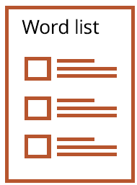

We explain what these words mean.

There is a list of these words on page 39.

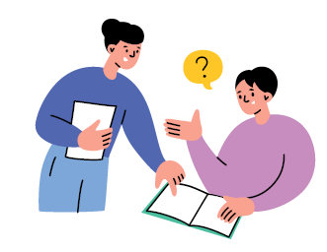

This Plan has a lot of information.

You can ask a friend or family member for help to read this Plan.

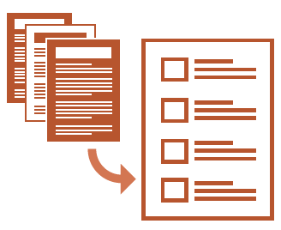

This Plan is a summary of another plan. That means it only includes the most important ideas.

You can find the full plan on our website at [arts.gov.au/equity](https://www.arts.gov.au/equity)

## Acknowledgements

### First Nations people

The Australian Government acknowledges Australia’s First Nations peoples as the Traditional Custodians of Country throughout Australia.

The Government recognises and respects their continuing connection to lands, waters and communities and pays respect to Elders past and present, and to all First Nations peoples.

The Government recognises the continuation of diverse cultural, spiritual and educational practices.

The Government acknowledges that self-determination is a human right for First Nations peoples.

This is enshrined in the United Nations Declaration of the Rights of Indigenous Peoples.

The Government thanks all First Nations people with disability who have generously shared their valuable knowledge and expertise to inform the development of *Equity: the Arts and Disability Associated Plan*.

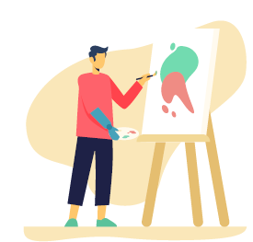

### People with disability

We recognise people with disability. They are important to Australia’s arts and culture.

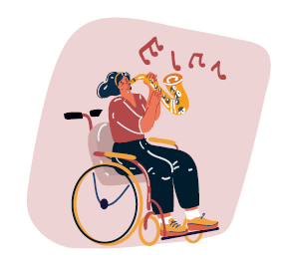

We know that each person has their own experiences in arts and culture.

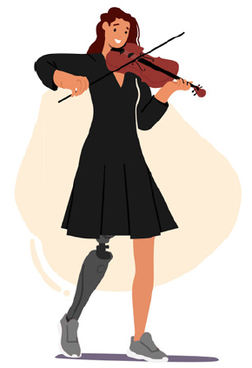

We thank **artists and arts workers** with disability and arts and disability organisations who helped us develop this Plan.

## What is in this Plan

EQUITY 1

The Arts and Disability Associated Plan 1

How to use this Plan 2

Acknowledgements 4

What is in this Plan 6

The words we use 8

Summary of the Foreword 9

How we made this Plan 10

Why we need this Plan 12

What this Plan is about 14

What we are going to do 17

Priority 1: Recognising d/Deaf and disabled artists and arts workers as central to our vibrant arts and cultural sector. 19

Priority 2: Strong and inclusive governments and organisations 22

Priority 3: Engaging the audience: fair, open and equitable access to arts and culture. 26

Important projects 28

Putting the Plan in action 30

Checking how the Plan is going 33

Word list 34

Contact us 40

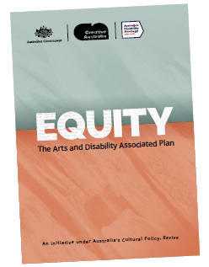

See the full report for more detail and for a list of references. [arts.gov.au/equity](https://www.arts.gov.au/equity)

## The words we use

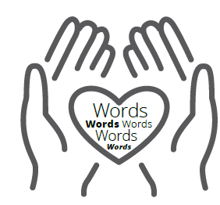

The words we use are important.

People with disability told us that they like different words to describe them.

There is not one word that works for everyone.

### In this Plan, we use these words:

* d/Deaf and disabled artists and arts workers

This means d/Deaf and disabled people who work in arts and culture.

### 

* people with disability

This means people with a disability. They may be in an audience or in the community.

* arts and cultural sector

This includes organisations and people involved in many different arts, such as:

* visual arts and crafts
* writing
* theatre, dance and music
* galleries, libraries and museums
* film and television
* digital games
* arts education and training
* Office for the Arts, Creative Australia and Screen Australia.

## Summary of the Foreword

Arts and culture belong to everyone.

Access to arts and culture for d/Deaf and disabled artists and arts workers and audiences with disability is a human right. It is important to the Government.

In January 2023, the Australian Government released a document called *Revive*: a place for every story, a story for every place. It is our cultural policy for the next five years.

*Revive* celebrates people’s stories and experiences in Australia and in our arts and culture.

The Australian Government also has the ***Australia’s Disability Strategy*** *2021–2031*.

The strategy supports action by all government organisations to improve the lives of people with disability. That includes the Australian Government and local, state and territory governments.

This Arts and Disability Associated Plan supports the *Revive* policy and Australia’s Disability Strategy.

We know there are many artists and arts workers with disability making great art.

The Plan is a map of what we will do to make arts and culture easy to access and fair for d/Deaf and disabled artists and arts workers, and for audiences with disability.

The Government worked with people with disability to write this Plan. We will also work with them to put the Plan in action.

## How we made this Plan

This Plan was developed by two Australian Government organisations.

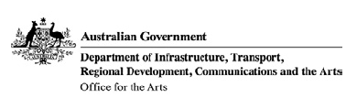

They are the Office for the Arts, Creative Australia, and Screen Australia.

The Office for the Arts helps:

* people take part in arts and culture
* organisations provide arts training
* organisations look after arts and culture, like museums.

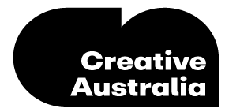

Creative Australia helps:

* artists and arts organisations to be creative
* organisations work together to support arts and culture
* make good decisions by doing research on arts and culture.

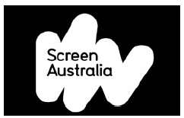

These organisations also consulted with Screen Australia.

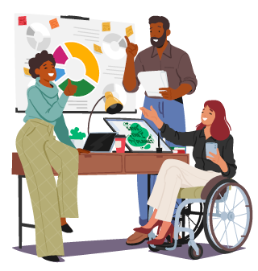

The Australian Government wants everyone to have the chance to take part in arts and culture.

Many people and organisations helped us make this Plan. So we talked to many people and organisations when we wrote this Plan.

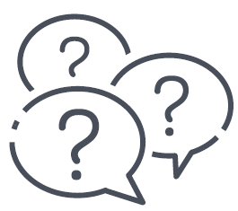

We talked to:

* d/Deaf and disabled artists and arts workers
* audience members with disability
* people and organisations from the arts and cultural sector
* First Nations people who work in the arts and cultural sector.

## Why we need this Plan

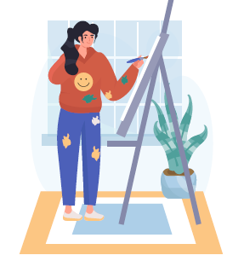

There are many d/Deaf and disabled artists and arts workers who make great art.

There are many organisations that help people take part in arts and culture.

And there are many people with disability who like to experience arts and culture.

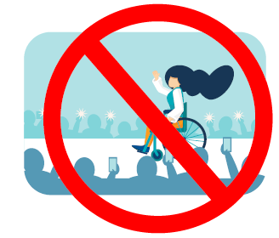

However, there are **barriers** that stop some people with disability getting involved in arts and culture.

A barrier is something that gets in the way.

A barrier to taking part in arts can be many things, for example:

* ableism: which is discrimination against people with disability
* a building that does not have easy access for artists, arts workers and audiences
* negative attitudes about people with disability
* not having as many services in areas away from the city
* the cost of services.

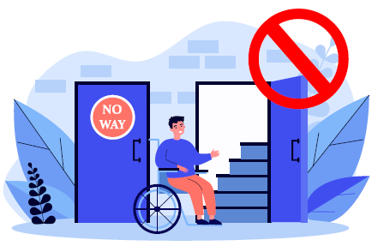



The Government knows that people with disability have their own personal experiences.



They may face many barriers in everyday life, including the arts.



They may also face other barriers, such as discrimination because of their abilities, their race, gender, sexuality, age, religion, culture or language.



These barriers can join up to make access and inclusion hard. This is called **intersectionality**.



This Plan will help remove barriers.

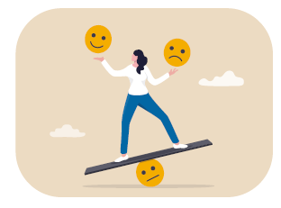

## What this Plan is about

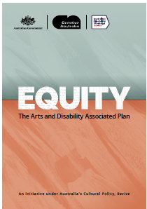

This Arts and Disability **Associated Plan** is a plan to make life better for people with disability.

We call it ‘the Plan’.

The Plan replaces the *National Arts and Disability Strategy*.

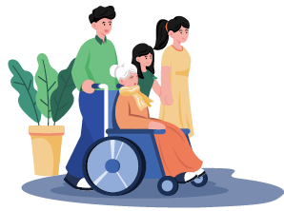

The Plan is about what we can do to make arts and culture more equitable, accessible and inclusive for:

* d/Deaf and disabled artists and arts workers
* audiences with disability.

**Equitable** means everyone has the same chance to take part in arts and culture.

**Accessible** means everyone can use it. This could be a building or place, transport, services or information.

**Inclusive** means everyone can take part and feel like they belong.

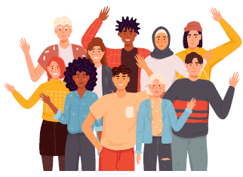

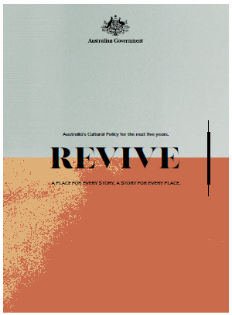

The Plan supports the Australian Government’s plans for the future. It supports:

* *Revive*: a place for every story, a story for every place.

This is the Australian Government’s cultural policy for the next five years.

A policy describes what an organisation wants to do.

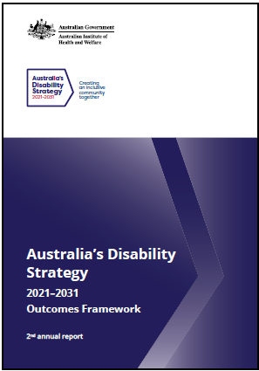

* *Australia’s Disability Strategy 2021–2031.*

This has actions for all levels of government to improve the lives of people with disability.

A strategy describes the actions a government will take.

All levels of government includes the Australian Government, state and territory governments and local governments.

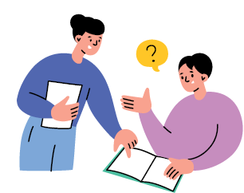

We will work with other arts, cultural and screen organisations in Australia because they can also work on removing barriers for people with disability.

We will help them to:

* make sure they think about arts, culture and disability when they are making plans

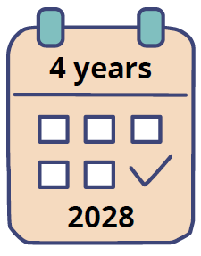

This Plan will last:

* for 4 years
* until 2028.

## What we are going to do

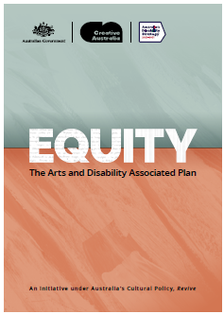

We made the Plan to help remove barriers in arts and culture.

The Plan has 3 priorities.

Priorities are important things we want to do.

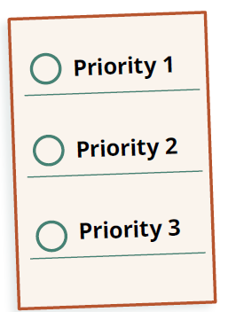

* Priority 1: Recognising d/Deaf and disabled artists and arts workers as central to our vibrant arts and cultural sector.

Central means at the centre or most important. Vibrant means lively and exciting.

* Priority 2: Strong and inclusive governments and organisations.
* Priority 3: Engaging the audience: fair,

open and equitable access to arts and culture.

Engaging means connecting with.

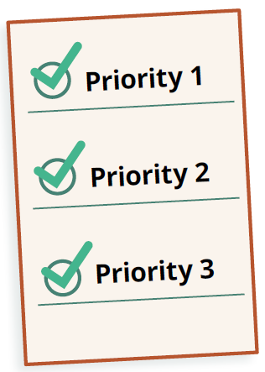

For these priorities, there are outcomes and actions.

Outcomes are the results we want to get.

Actions are the things we will do to get the outcomes.

We talk about the priorities, outcomes and actions in the next pages.

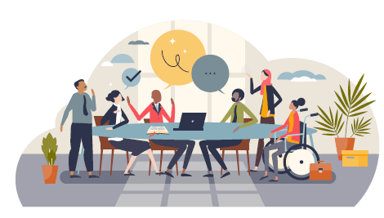

We will set up an **Implementation Advisory Group**.

* This will be a group of people with disability who have experience in arts and culture.
* They will give advice to the Office for the Arts and Creative Australia.
* They will be paid.

## Priority 1: Recognising d/Deaf and disabled artists and arts workers as central to our vibrant arts and cultural sector.

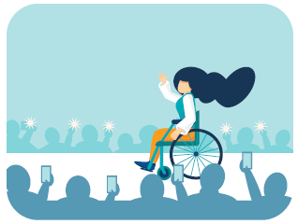

### The outcomes we want

The Australian Government wants d/Deaf and disabled artists and arts workers to:

* be seen in arts and culture in Australia
* be treated the same as artists and arts workers without disability
* feel safe in arts and culture places
* connect with artists and arts workers and arts organisations
* develop skills and experience in their art
* find jobs in arts and culture.

### The actions we will do to get our outcomes.

### We will support new arts projects and work.

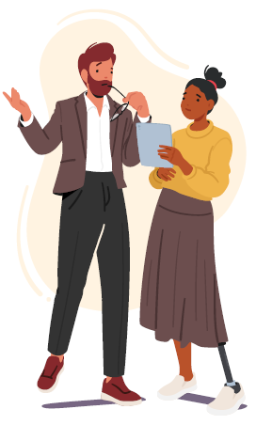

This will create more chances for d/Deaf and disabled artists and arts workers to:

* get a job in arts and culture
* learn skills and get experience
* connect with other people and organisations.

### We will set up regular arts and disability meetings

This group will be called the National Arts and Disability Forum and Gathering.

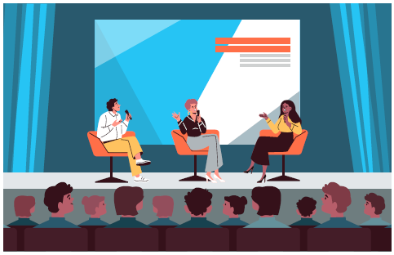

It will:

* help d/Deaf and disabled artists and arts workers
* bring people in arts and culture together
* connect people to jobs and projects. We will support career development for d/Deaf and disabled artists and arts workers.

The Arts and Screen Employment Pathways Pilot Program will:

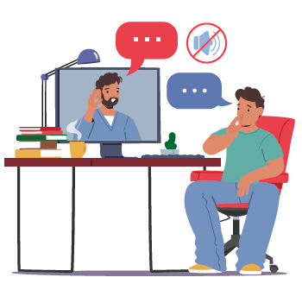

* put people in short-term jobs in arts and culture
* give them a safe place to learn, get more skills and experience.

### We will make it easier for d/Deaf and disabled artists and arts workers to get an arts grant or join in other government programs.

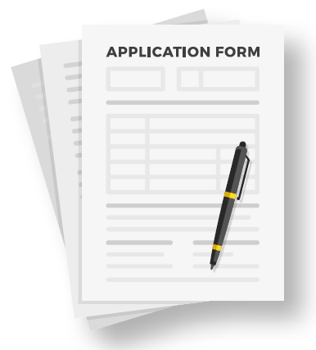

We will:

* make the steps to apply easier
* provide clear information online
* make sure the people who work on the grants know about the skills of d/Deaf and disabled artists and arts workers.

## Priority 2: Strong and inclusive governments and organisations

### The outcomes we want

The Australian Government wants:

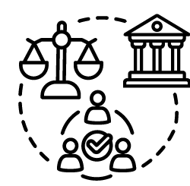

* governments and arts and cultural organisations to be more equitable, accessible and inclusive for people with disability

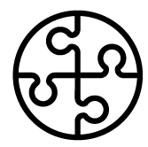

* more people with a disability to be involved in arts and cultural organisations

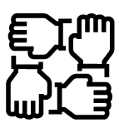

* all levels of government to work together to support the arts and cultural sector.

### The actions we will do to get our outcomes

### We will help arts and cultural organisations make improvements to be more equitable, accessible and inclusive.



We will:

* provide money for projects that make improvements

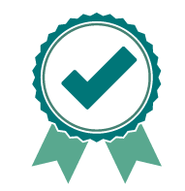

* provide information about best practice
* ask them to have a disability action plan



* ask them to make sure their grants support equitable, accessible and inclusive projects.

Best practice means the latest information about what works.

Disability action plan is a plan that describes how an organisation will become inclusive and accessible for people with disability.

Grants means money that the government provides for specific projects.

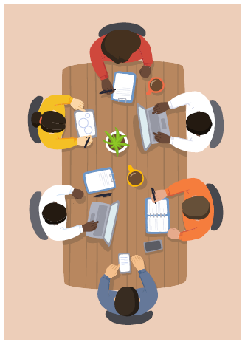

### We will work with these governments to: support them to provide clear advice and work together

We will:

* support opportunities to put people with disability on the boards of arts and cultural organisations

Boards are groups of people who help run organisations and make sure they are doing what they should be doing.

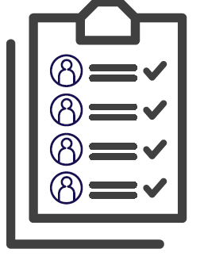

The Office for the Arts has a register of people who would like to be on arts and cultural boards and committees.

A register is a list that includes people’s names and information about their skills and experiences.

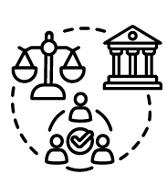

### We will work with other parts of the Government on issues that affect people with disability who want to be involved in arts and culture:

* Some Government policies affect people with disability who want to work in the arts or make art.
* We will work with other Government departments and agencies to help make these policies better.
* We will create information about arts education and careers for d/Deaf and disabled artists and arts workers.

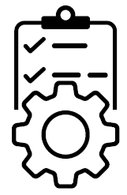

### We will work with local, state and territory governments to support the arts and cultural sector to be more equitable, accessible and inclusive.

We will work with these governments to:

* support them to provide clear advice and work together
* help them think about how government policies affect people with disability who want to work in the arts or make art
* support them to make policies that are better for people with disability.

### We will support the arts and cultural sector to be more equitable, accessible and inclusive.

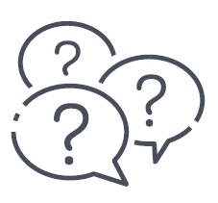

We will help them to:

* think about arts, culture and disability when they make a plan

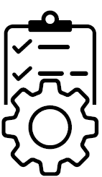

* solve issues that affect d/Deaf and disabled artists and arts workers, and people with disability who want to take part in arts and culture.

## Priority 3: Engaging the audience: fair, open and equitable access to arts and culture.

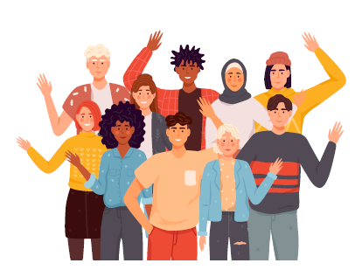

### The outcomes we want

The Australian Government wants people with disability to:

* connect with stories that mean something to them
* have easy and safe access to arts and culture
* share arts and cultural experiences with the wider community.

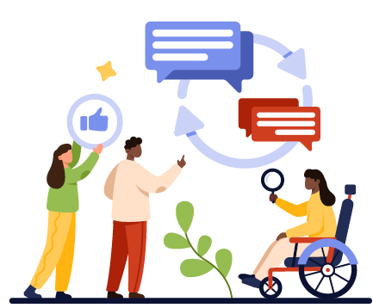

### The actions we will do to get our outcomes

### We will help people with disability connect with stories that have meaning for them

We will support people to:

* have jobs and careers in arts and culture
* be leaders in arts organisations
* tell real stories that mean something to them and their audiences.

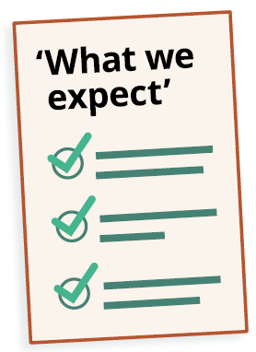

### We will help the arts and cultural sector become more inclusive and accessible.

We will:

* be clear about what inclusive and accessible means and what we expect organisations to do
* make sure organisations are trying to be inclusive and accessible before we give them money for projects
* work with local, state and territory governments and arts and cultural organisations to remove barriers.

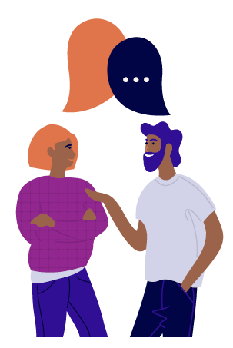

### We will help audiences with disability have a good experience in arts and culture.

We will:

* talk to people with disability to understand their needs
* ask organisations to think about how to make their events more inclusive.

## Important projects



### The Australian Government is providing $8.1 million for actions in this Plan.

This includes:

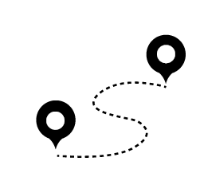

* $2.25 million for the Arts and Screen Employment Pathways Pilot Program



* $2 million to help Creative Australia Arts and Disability programs reach more people

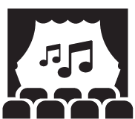

* $1.2 million to help make live music places and music festivals more accessible

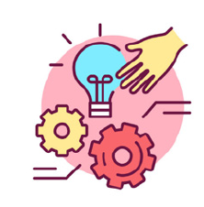

* $1 million for arts and disability services



* $600,000 to continue the National Arts and Disability Awards and Arts and Disability Fellowship

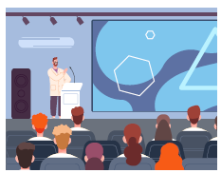

* $600,000 for a National Arts and Disability Forum and Gathering

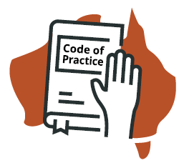

* $250,000 for a National Arts and Disability Code of Practice or guidelines

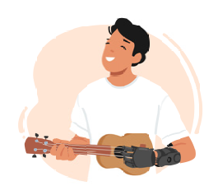

* $200,000 for First Nations arts and disability needs and projects.

A fellowship is a type of grant.

A code of practice is a set of rules about what people and organisations should do.

## Putting the Plan in action

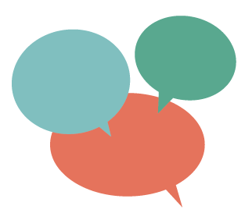

### To make this Plan we listened to people with disability.

### We will also listen to people with disability to put this Plan in action.

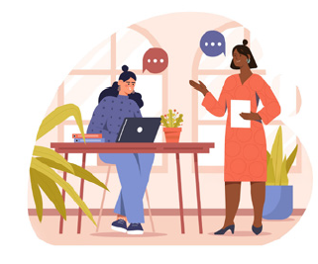

The Office for the Arts and Creative Australia will do the actions to deliver this Plan.

To decide on the actions, they will work with:

* Screen Australia
* d/Deaf and disabled artists and arts workers
* people with disability
* the arts and cultural sector
* the **First Nations Board**
* the Implementation Advisory Group.

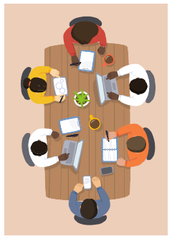

The First Nations Board is a group of First Nations leaders, artists and arts workers. They give advice to Creative Australia on First Nations arts and culture.

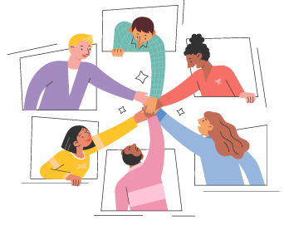

The Implementation Advisory Group is a group of people with disability who have experience in arts and culture. They give advice to the Office for the Arts and Creative Australia.

### This Plan will help organisations make changes over time.

We will:



* provide money for actions that help the arts and cultural sector make change

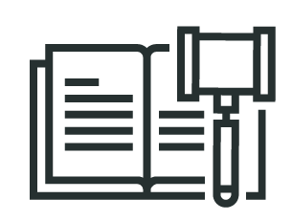

* give advice or use rules to help organisations change

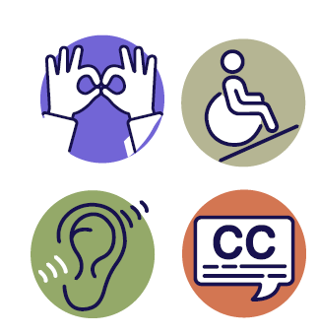

* connect with the arts and cultural sector so they understand how to make arts and culture accessible, inclusive and equitable.

## Checking how the Plan is going

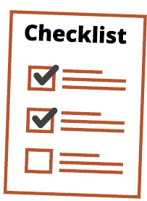

### We will create a way to check how well the Plan is going.

This will be called the evaluation framework.

The evaluation framework will help us measure the success of actions in this Plan.

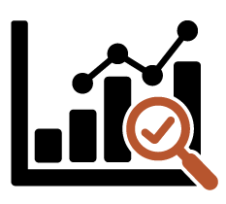

Checking how the actions are going will:

* show us where they are going well
* tell us if we need to change our actions
* help us work out the next steps to take.

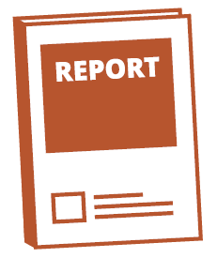

We will write a report about how our Plan is going.

We will share the report with you and with the arts and cultural sector.

## Word list

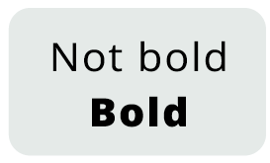

This list explains what the bold words in this document mean.

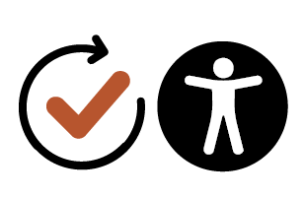

### Accessible

If something is accessible, everyone can use it.

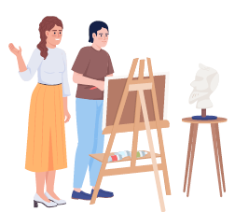

### Artist/s, arts worker/s

Artists and arts workers are people involved in arts and cultural activities. This includes:

* people working in arts and cultural organisations, including in screen and digital games

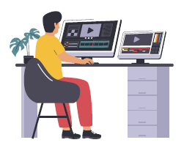

* people making arts and cultural products in other organisations.

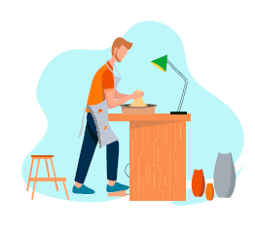

### Arts and cultural sector

This refers to all of the organisations and people involved in many different arts.

It can include:

* visual arts and crafts

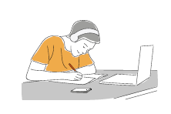

* writing
* theatre, dance and music

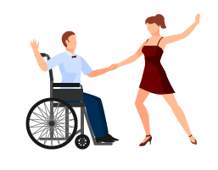

* galleries, libraries and museums

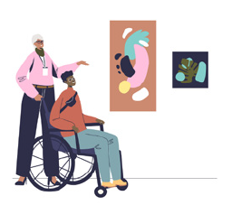

* film and television
* digital games
* arts education and training

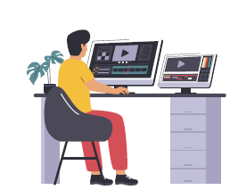

* Office for the Arts, Creative Australia and Screen Australia.

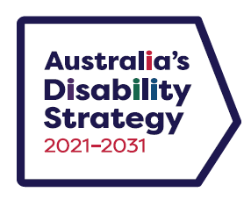

### Associated Plan

This is a plan about improving life

for people with disability in Australia.

It was made to deliver the vision of Australia’s Disability Strategy.

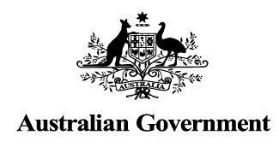

### Australian Government

In this Plan, the ‘Australian Government’ or ‘the Government’ means the Commonwealth Government (not state and territory or local governments) and its departments and agencies.

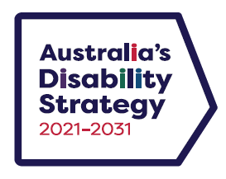

### Australia’s Disability Strategy

This is Australia’s national disability plan. It guides actions by local, state and territory governments to improve the lives of people with disability.

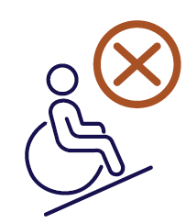

### Barrier/s

Barriers are things that get in the way. Barriers can stop people with disability from taking part in arts and culture.

Barriers can include:

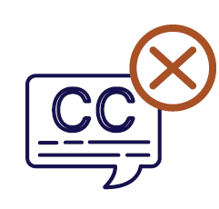

* buildings that don’t have a ramp or accessible toilets
* people’s attitudes, like thinking that people with disability cannot do certain things.

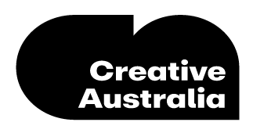

### Creative Australia

Creative Australia is a government organisation that gives money and advice for the arts. It provides grants and awards for people and organisations to support Australian artists. It also does research and supports arts and cultural organisations that speak for people with disability.

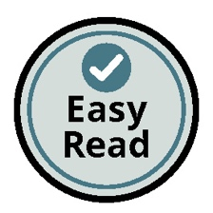

### Easy Read

Easy Read is a way to present information to make it easier to understand. It uses simple words, short sentences, clear layouts, and images or photos to help describe the information.

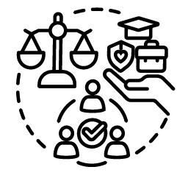

### Equity

Equity is about everyone having fair access to the same opportunities.

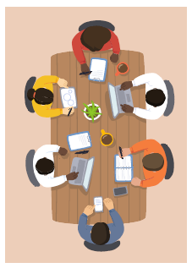

### First Nations Board

A group of First Nations leaders, artists and arts workers. They give advice to Creative Australia on First Nations arts and culture.

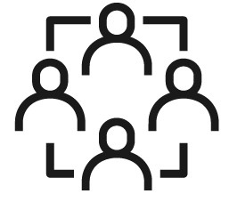

**Inclusive**

When something is inclusive, everyone:

* can take part
* feels like they belong.

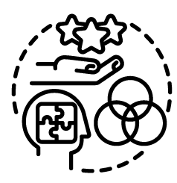

### Intersectionality

When barriers join up. People who face barriers to arts and culture may also face discrimination because of their abilities, their race, gender, sexuality, age, religion, culture or language. These barriers can join up to make access and inclusion hard.

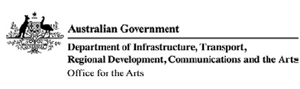

### Office for the Arts

The Office for the Arts is part of the Australian Government Department of Infrastructure, Transport, Regional Development, Communications and the Arts.

The Office for the Arts provides money for important arts organisations, including arts training organisations and organisations that look after Australian art, such as museums, libraries and galleries.

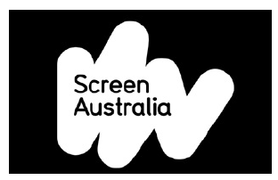

### Screen Australia

Screen Australia is the government organisation that supports people who make Australian film, television, documentaries and digital games.

## Contact us

Email us: [Arts.Disability@arts.gov.au](mailto:Arts.Disability@arts.gov.au)

See our website: [www.arts.gov.au/equity](https://www.arts.gov.au/equity)