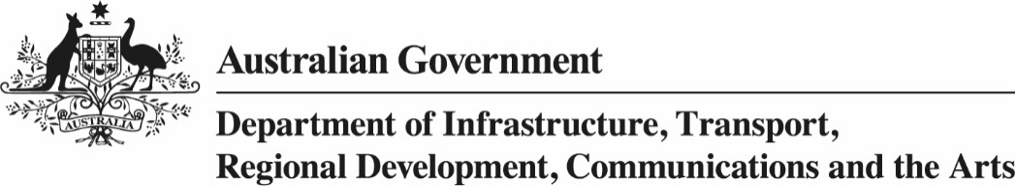

# Cultural Gifts Program—Nomination of a Valuer

Section 30-210 of *the Income Tax Assessment Act* 1997

**July 2022**

## Completing this form

This form must be completed electronically.

Ensure that ALL sections are completed. Please ensure that you address all the assessment criteria thoroughly, however keep your responses concise and do not repeat information.

## How is the potential valuer’s application assessed?

Under section 30-210 of the *Income* *Tax Assessment Act 1997*, the Arts Secretary may approve a person to be a valuer of a particular kind of property after having regard to the person’s:

* qualifications, experience and knowledge in valuing that kind of property,
* knowledge of the current GST inclusive market value of that kind of property, and
* standing in the professional community.

The department will make an assessment of the application **based on the above criteria** and make a recommendation to the Secretary. The Secretary will decide whether to approve the applicant as a valuer for the purposes of the Program.

## How do we use the information you provide?

Any personal information you provide in this application form is used for the purpose of administering the Cultural Gifts Program. Such information may be provided to the Minister for the Arts, the Australian Taxation Office, the applicant’s referees, any other relevant party in the administration of the program and as required by law.

## Name of applicant

|  |  |
| --- | --- |
| Applicant name: |  |
| Applicant telephone number: |  |
| Applicant mobile number: |  |
| Applicant fax number: |  |
| Applicant email address: |  |
| Postal address: |  |

## Nominated by

|  |  |
| --- | --- |
| Nominator name: |  |
| Position—director, deputy director or equivalent: |  |
| Institution: |  |

## General questions

|  |  |
| --- | --- |
| If you have read the applicant’s application, do you wish to make any comments on any claims made in the application?  If you have not read the applicant’s application please provide a reason. |  |
| How long have you known the applicant or how long has the institution been dealing with the applicant, and in what professional circumstances? |  |
| Can you comment on the suitability of the applicant as a valuer for each nominated class of property under the Cultural Gifts Program? |  |
| Can you comment on whether the applicant’s qualifications, experience and knowledge are appropriate to enable him or her to provide a current market valuation for property in each nominated class of property and on what do you base your opinion? |  |
| Can you comment on the individual’s standing in the professional community, particularly in relation to the individual’s suitability to be an Approved Valuer under the Cultural Gifts Program? |  |

I certify that the information that I have provided is to the best of my knowledge true and that it is in no way misleading or deceptive.

|  |  |
| --- | --- |
| Signature: |  |
| Nominator name: |  |
| Position director, deputy director or equivalent: |  |
| Date: |  |