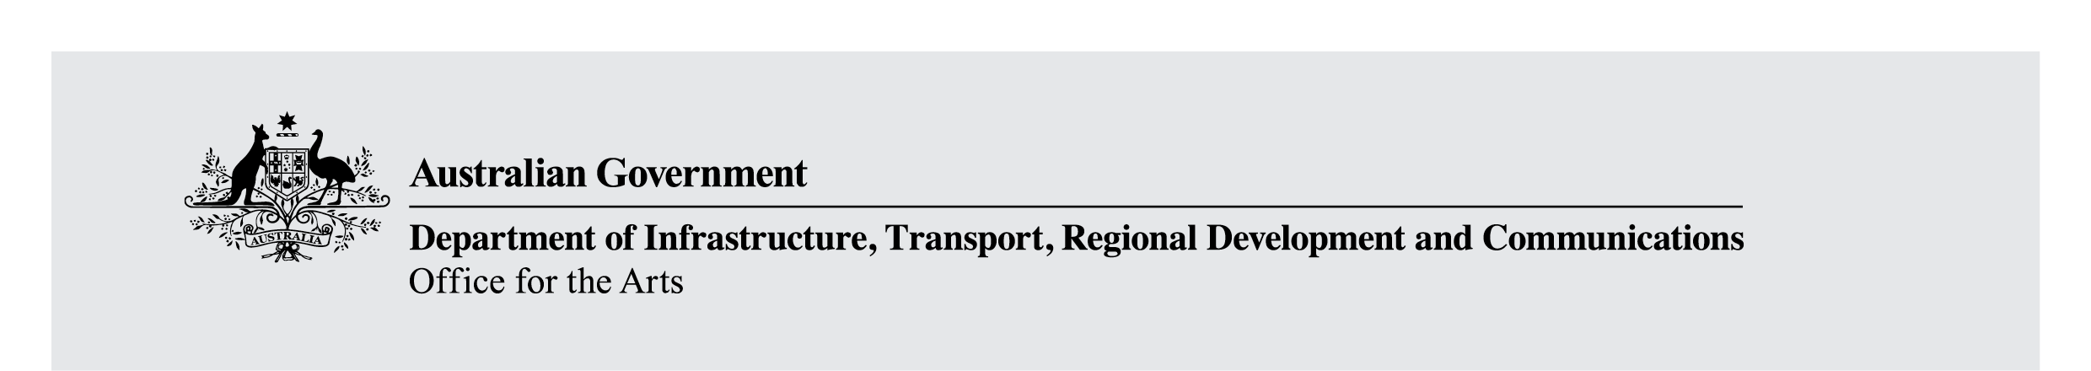

Consultation Paper on Growing the Indigenous Visual Arts Industry
September 2020
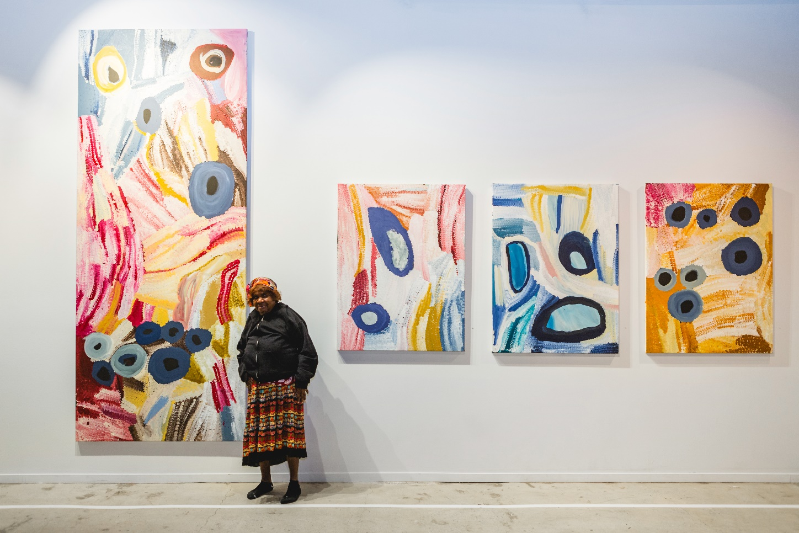

Contents
The National Indigenous Visual Arts Action Plan 3
This consultation paper 4
How you can comment 4
Next steps and further information 4
The importance of Indigenous Art 4
Australia Government support for Indigenous visual art 5
Government Response to House of Representatives Inquiry 7
Issues and questions 8
Theme 1: Sustainable growth 8
What have you told us? 8
What are we doing? 8
What do you think? 8
Theme 2: Capacity building 9
What have you told us? 9
What are we doing? 9
What do you think? 9
Theme 3: Access to Market 10
What have you told us? 10
What are we doing? 10
What do you think? 10
Theme 4: Legal Protections 11
What have you told us? 11
What are we doing? 11
What do you think? 11
Front cover: Bugai Whyoulter with her artwork at The Goods Shed, photograph by Taryn Hays, image courtesy of FORM and Martumili Artists, 2019.

The National Indigenous Visual Arts Action Plan
The Australian Government recognises that Aboriginal and Torres Strait Islander Art is an important way for Indigenous Australians to tell stories, share culture, understand and explore Country and history, build community, and drive economic opportunities.
This year, the Australian Government is developing an Action Plan to support Aboriginal and Torres Strait Islander artists, and their cultural and economic interests.
In March, Australia began to experience the impacts of the COVID-19 pandemic, and the Indigenous visual arts industry was dramatically impacted. Access to remote Indigenous communities was restricted to ensure the health and safety of residents. Art centres, galleries and studios closed or scaled back their activities. Art fairs and industry events have rapidly adapted to digital platforms and many were required to cancel or postpone.
The shutdown of domestic and international travel, combined with the economic downturn, has led to a drop in the primary market for Indigenous artwork, leading to an immediate and significant loss of sales and income for artists, art centres and many art market professionals. The flow-on effects have been felt across the Indigenous visual arts sector.
This Action Plan comes at a time when the Industry is considering the full long-term effects of COVID-19. Australian Government whole of economy measures such as JobKeeper and JobSeeker, introduced to help businesses and individuals during the pandemic, have gone some way to reducing the immediate negative impacts. Targeted support for art centres and art fairs funded through the Indigenous Visual Arts Industry Support program has also provided much-needed cash flow to ensure viability during this difficult time. We are now looking towards the future, and considering what action needs to be taken to assist the sector to rebuild following COVID-19.
Action Plans help to give everyone a clear work plan. They also help to make it clear what the Government does now and plans to do, so that that we can all work together.

We would like to hear what you think
It is important that the Action Plan is based on the views of the Indigenous visual arts sector. The feedback we receive in response to this consultation paper will assist to develop the Action Plan.
We would like to hear from anyone involved with the Indigenous arts sector who wants to contribute. This might include artists, art centre directors, arts workers, art centre managers, art dealers, purchasers, collectors, industry bodies or peak bodies representing these groups.
Some people have provided feedback to other consultations. We will incorporate that feedback into this Action Plan. As this is an important new initiative, we want to make sure that everyone has an opportunity to guide and shape the outcomes.

This consultation paper
This paper includes information on things the Government is currently doing to support artists, art centres and the industry; and information on things we have heard about in the past. This paper asks questions about what you think about certain issues.

How you can comment
In writing: Send your comments by mail or email until 18 December 2020.
Post: Visual Arts and Design Section
Office of the Arts
GPO Box 2154
CANBERRA ACT 2601
Email: IVA@arts.gov.au
In person: COVID-19 has significantly impacted on travel and public gatherings. Face-to-face consultations will be scheduled when it is safe to do so, in line with health advice. We will provide up-to-date information about face to face consultations on the Office for the Arts’ website at: www.arts.gov.au.
Non-written submissions: Please contact email IVA@arts.gov.au or call the Visual Arts and Design Section at the Office of the Arts on 02 6271 1000 to discuss your needs.

Next steps and further information
The Australian Government will use feedback from the national consultation to develop a National Indigenous Art Visual Action Plan. For further information on providing comments or the Action Plan please visit the Office for the Arts website (www.arts.gov.au), subscribe to twitter or email IVA@arts.gov.au or call the Visual Arts and Design Section at the Office of the Arts on 02 6271 1000.

The importance of Indigenous Art
The Australian Government recognises that Indigenous art is important to Australia and Australians. It sustains and strengthens Indigenous communities, is a vital part of Australia’s identity, and provides opportunities for employment, skills development, and income.
Indigenous art also makes a large contribution to the economy. Australia’s Indigenous tourism has an estimated value of $5.8 billion annually, catering to 910,000 international visitors and 688,000 overnight domestic trips in 2016.
In 2018–19, organisations supported by the Australian Government’s Indigenous Visual Arts Industry Support (IVAIS) program participated in over 900 exhibitions and events, achieving $26.5 million in primary art sales. It is estimated that each year these activities contribute approximately $70 million to the Australian economy.
In addition in 2018–19, the four Indigenous art fairs supported through the IVAIS program hosted 96,402 visitors, achieved $4.3 million in art sales, and featured work by 2715 artists.
Australia’s Indigenous visual art industry has seen significant growth since the Australian Government began providing support in the early 1970s.
Today, the industry is made up of a strong framework of art centres, commercial galleries, auction houses, wholesalers, dealers and independent artists working in a range of ways, including being represented by agents or commercial galleries, contracted as designers or operating as sole traders.
Until the start of COVID-19, art centre sales had been growing for almost a decade. Between 2011–12 and 2018–19, the average sales of art centres have grown by 53.4 percent. This is still 11.7 percent lower than at the market’s peak in 2007-08, before the Global Financial Crisis, which caused a drop in sales of work by Indigenous artists.
But today art centres are more financially independent, and the proportion of income from grants has fallen to its lowest level for over a decade - at around 40 percent of total average income. Many Aboriginal and Torres Strait Islander artists have won much critical acclaim, and are represented in major public and private collections in Australia and overseas. Australian Indigenous visual art is internationally recognised and sought after for its quality, innovation and cultural richness.
Aboriginal and Torres Strait Islander artists are also investing money earnt through art back into their communities. Artists and art centres are now essential contributors to important social and health initiatives on Country, strengthening community outcomes and investing in their communities’ futures.
It is difficult to identify at this stage the full impact of COVID-19 on the Indigenous art sector. What is known however is that income from sales of artwork has been significantly impacted by the pandemic across all parts of the sector. It will take some time and dedicated effort to rebuild the market to its previous levels.

Australia Government support for Indigenous visual art
One of the Australian Government’s priorities is to support the Indigenous arts industry to grow, to deliver economic opportunities for Aboriginal and Torres Strait Islander artists and to promote ethical dealing.
One of the Australian Government’s priorities is to support the Indigenous arts industry to grow, to deliver economic opportunities for Aboriginal and Torres Strait Islander artists and to promote ethical dealing.
In response to the COVID-19 pandemic, on 9 April 2020, the Australian Government announced it would provide an additional $7 million funding which will assist to make sure that Indigenous Art Centres funded through the Indigenous Visual Arts Industry Support program are well-placed to re-enter the market once the COVID-19 crisis has passed, and that IVAIS-funded Art Fairs are in place to assist to build the market for art by Aboriginal and Torres Strait Islander people.
The Australian Government is proud to deliver significant support to the sector:
- The IVAIS program provides approximately $21 million per annum to around 80 Indigenous-owned art centres, as well as a number of art fairs, regional hubs and industry service organisations.
- This provides opportunities for approximately 8,000 Aboriginal and Torres Strait Islander artists and more than 500 Aboriginal and Torres Strait Islander arts workers.
- The IVAIS program funds five service organisations that support artists and art centres, and work to raise professional and ethical standards across the industry. These are: Desart; Arnhem, Northern and Kimberley Artists Aboriginal Corporation (ANKA); Indigenous Art Centre Alliance (IACA); Ananguku Arts (Ku Arts); and Aboriginal Art Centre Hub of Western Australia (AACHWA).
- The Indigenous Languages and Arts (ILA) program invests around $20 million per year to support Aboriginal and Torres Strait Islander peoples to express, preserve and maintain their cultures through languages and arts activities around Australia.
- The ILA program includes operational funding support to a network of 21 Indigenous Language Centres across the country working on capturing, preserving and maintaining over 150 Aboriginal and Torres Strait Islander languages.
- The ILA program also supports Aboriginal and Torres Strait Islander peoples to develop, produce, present, exhibit or perform Indigenous arts projects that showcase Australia’s traditional and contemporary Indigenous cultural and artistic expressions.
- Australian Government funding delivered through the Australia Council supports Indigenous visual artists as well as Indigenous visual arts organisations, including industry bodies, art centres, galleries, festivals and cultural organisations.
- The Australia Council delivers the First Nations Arts Awards, including the prestigious Red Ochre Award recognising a senior male and senior female Aboriginal and Torres Strait Islander person for outstanding lifetime achievement in the arts.
The Australian Government also funds initiatives which further support the sector:
- The Arts Law Centre of Australia’s Artists in the Black program, a specialised legal service for Aboriginal and Torres Strait Islander artists, communities and arts organisations.
- The Indigenous Art Code which promotes ethical trading and action in relation to inauthentic Indigenous ‘style’ products.
- Desart is trialling the use of digital product labelling with three Indigenous-owned art centres in Western Australia, the Northern Territory and Far North Queensland. Additional art centres have expressed interest in adopting the new technology across 2020.
- The Resale Royalty Right for Visual Artists Scheme was introduced in 2010, giving visual artists five per cent of the price of eligible artworks resold commercially for $1,000 or more. To date, 64 per cent of artists benefiting from the scheme are Aboriginal and Torres Strait Islander people who have received 37 per cent of the royalties by value.

Government Response to House of Representatives Inquiry
The Government has responded to the House of Representatives Standing Committee on Indigenous Affairs report on the impact of inauthentic art and craft in the style of First Nations peoples.
The report followed an extensive inquiry involving consultation with the sector. Many stakeholders made submissions and appeared before the Committee to give their views. We will consider those views in context of the Indigenous Visual Art Action Plan.
The Committee’s final report made eight recommendations to address the challenges facing the Indigenous arts sector in relation to inauthentic products.
The Government includes the following commitments, which will be incorporated in the Indigenous Visual Art Action Plan.
- That the Productivity Commission will commission a study into the nature and structure of the Indigenous market and policies to address deficiencies in the market
- Additional funding to the Indigenous Art Code from 2019–20 with a national funding commitment from the Australian Government and the states and territories, to support the Code’s ongoing work
- Opportunities for targeted support for art centres will be considered under the National Indigenous Australians Agency’s Indigenous Business Sector Strategy
- Tourism Australia will disseminate information to international tourists and the Australian Competition and Consumer Commission will update education for consumers and undertake compliance initiatives with wholesalers and retailers
- IP Australia will continue to work with Indigenous communities to consider the viability of a certification trade mark (CTM) for authentic products
- A trial of digital labels for authentic Indigenous products has been funded by the Australian Government. Desart is running the trial in consultation with three remote art centres and,
- An assessment of the scope and feasibility of new stand-alone legislation protecting Indigenous Cultural Intellectual Property will be undertaken, including consultation with Indigenous communities.

Issues and questions
The Government is keen to hear views on all topics related to the issues raised in this paper. Some particular areas of interest are raised in the questions below.

Theme 1: Sustainable growth

What have you told us?
You have told us that Indigenous art and culture are closely linked and dependent on each other.
You have told us that growth of the Indigenous visual art market needs to happen in a way that supports Indigenous culture and is sustainable, over a long time.

What are we doing?
We currently:
- Through the IVAIS program, support a network of 80 art centres which play an important role in enhancing social cohesion, promoting respect for traditional knowledge and providing leadership opportunities.
- Fund the ILA program to support Aboriginal and Torres Strait Islander peoples to express, preserve and maintain their cultures through languages and arts activities around Australia.
We will:
- Conduct a Productivity Commission study into the nature and structure of the Indigenous arts and crafts market, to address deficiencies in the market.

What do you think?
- What practical actions do you think will assist to rebuild the market in a sustainable way?
- What do you like or dislike about how the market currently works?
- What questions would you like answered in the Productivity Commission study?
- Different words have different meanings for different people. Should we use ‘Aboriginal and Torres Strait Islander people’ or ‘First Nations people’ in the Action Plan?
- What do you understand ‘authentic Indigenous art’ to mean? What type of artwork should be included in this definition?

Theme 2: Capacity building

What have you told us?
You have told us that there need to be clear professional pathways for Aboriginal and Torres Strait Islander artists and arts workers.
You have told us that the framework of support for artists could be stronger, with support for infrastructure that enables the creation of quality authentic Indigenous art.

What are we doing?
We currently:
- Through the IVAIS program, provide professional opportunities for over 8,000 Aboriginal and Torres Strait Islander visual artists and around 500 Aboriginal and Torres Strait Islander arts workers, most living in remote or very remote communities as well as:
- Fund the industry service organisations who provide professional opportunities for arts centres and artists.
- Support art fairs and marketing events, regional hubs and industry service organisations across Australia.
We will:
- Investigate opportunities for targeted support for art centres under the National Indigenous Australians Agency’s Indigenous Business Sector Strategy.

What do you think?
- What skills do you think are important in the industry? What ways do you build those skills? What would help you to build those skills?
- Do you get the support and materials you need from your art centre?
- Is there more that can be done to encourage the development of Indigenous-owned and operated businesses in the industry?

Theme 3: Access to Market

What have you told us?
You have told us that consumer access to quality authentic art is limited, particularly internationally, and this restricts artists’ professional and economic opportunities.
You have told us that it can be difficult for remote art centres and independent artists to engage with new markets.

What are we doing?
We currently:
- Through IVAIS, support Indigenous art fairs which connects Aboriginal and Torres Strait Islander artists to consumers and collectors.
- Maintain the Resale Royalty Right for Visual Artists scheme which gives proper recognition of artists’ on-going rights in their work, and additional income through royalties derived from commercial resales of their art.
- Fund a digital labelling trial for authentic products which is being conducted by Desart in consultation with three remote art centres.
We will:
- Investigate options on how to guide consumers, including domestic and international tourists, on the purchase of authentic Indigenous products and the role of the Australian Consumer Law.
- Grow the Artbank Indigenous art collection and promote it through Australian diplomatic missions.

What do you think?
- What can be done to assist artists to better connect with the art market?
- How can digital technologies overcome the challenges of remote locations?
- How significant has selling artwork online been for your art centre through COVID-19? How could you improve how your art centre sells work online?
- Is there more that needs to be done to engage with the international arts market as well as tourists in Australia?
- If overseas activities were to be supported, would this assist in engaging in the international market and do you consider this should be a priority?

Theme 4: Legal Protections

What have you told us?
You have told us that the current framework protecting Indigenous cultural expressions is strong, but more could be done to make sure that cultural expressions cannot be used by others for commercial gain.

What are we doing?
We currently:
- Maintain the Australian Consumer Law which prohibits conduct that may be misleading or deceptive, or making false or misleading representations.
- Fund the Indigenous Art Code to promote ethical trading and action in relation to inauthentic Indigenous ‘style’ products.
- Fund the Arts Law Centre of Australia to deliver the Artists in the Black program which provides specialised free or low-cost tailored legal assistance for Aboriginal and Torres Strait Islander artists.
- Support the Australia Council to develop protocols for working with Indigenous artists, including in the visual arts sector, setting out the legal, ethical and moral considerations for the use of Indigenous cultural material.
We will:
- Work with Indigenous communities to consider the viability of a certification trade mark scheme for authentic products.
- Assess the scope and feasibility of providing greater protections for Indigenous Cultural Intellectual Property.

What do you think?
- Is the current framework protecting Indigenous cultural expressions good enough?
- Should there be a mandatory Indigenous Art Code? If so, how do you think that should work?
- Do you like the idea of a certification trade mark scheme for authentic products? How do you think it should work?
- Do you like the way the Resale Royalty Scheme works?
- Is there more that could be done to increase awareness of moral, cultural and intellectual property rights?
- How do you think that Indigenous Cultural Intellectual Property protections could work in practical terms?

