

# Buying legally—making sure it’s above board

**August 2022**

Before buying cultural property, do your research.

## The seller

* Verify the identity of the seller.
* Buy from a member of a professional trade association.

## The object

Check the object against:

* The Movable Cultural Heritage Prohibited Exports Register.
* The databases of stolen art such as:

**The Art Loss Register**  
[www.artloss.com](http://www.artloss.com)

**Nazi Looted Art**  
[www.lootedart.com](http://www.lootedart.com)

**INTERPOL’s Stolen Works of Art**  
<https://www.interpol.int/en/Crimes/Cultural-heritage-crime/Stolen-Works-of-Art-Database/Application-form> to-access-INTERPOL-s-Works-of-Art-Database

**ICOM Red Lists of cultural objects at risk**  
[www.icom.museum/en/resources/red-lists](http://www.icom.museum/en/resources/red-lists)

## Documentation

Check any documentation about the history of the object, for example:

* Is there a history of ownership relating to the object?
* Is there a certificate of authenticity?
* Is there a condition report available?
* If the object comes from a foreign country is there an export permit?
* If you buy the object ensure that you have a written invoice, signed and dated by the seller, with their name, address and full details of the object.

**Before buying cultural property, do your research to make sure it’s above board.**

## International cultural heritage laws

### UNESCO

If the object comes from a foreign country check the relevant international cultural heritage law on the UNESCO website.

<https://en.unesco.org/cultnatlaws>

## Reporting art crime

### Crime Stoppers Australia

If you have any suspicions about an object and believe that a criminal offence has taken place, you can report it to your local police or Crime Stoppers.

**Phone:** 1800 333 000

**Website:** [www.crimestoppers.com.au](http://www.crimestoppers.com.au)

## Contact us

### Cultural Property Section

Department of Infrastructure, Transport, Regional Development, Communications and the Arts

**Phone:** 1800 819 461  
**Website:** arts.gov.au/movable  
**Email:** [movable.heritage@arts.gov.au](mailto:movable.heritage@arts.gov.au)  
**Post:** GPO Box 2154 Canberra ACT 2601

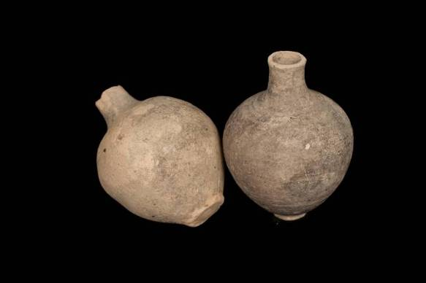

**Jordanian pots**Hasemite Kingdom of Jordan  
Image courtesy © Department of the Prime Minister and Cabinet