

# Australian Government International Exhibitions Insurance (AGIEI) Program

## Acknowledgment requirements

All recipients of AGIEI funding must acknowledge the support of the Australian Government in all publicity, publications and other materials. This includes catalogues, brochures, fliers, posters and advertisements as well as media releases.

### Logo

The AGIEI logo is to be included in a prominent place on all advertising and promotional material associated with the exhibition.

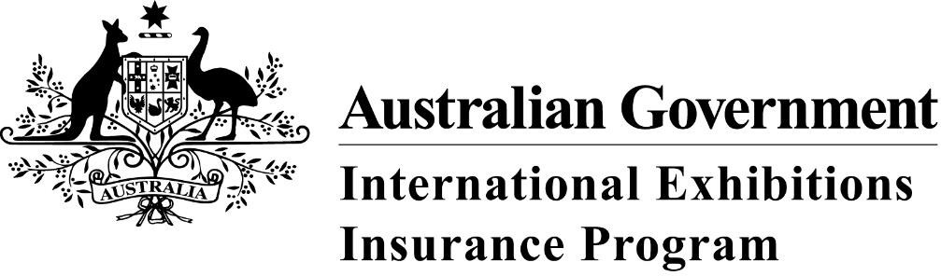

Versions of the logo suitable for hardcopy and electronic publishing can be downloaded from the Department of Communications and the Arts website at [www.arts.gov.au/agiei-program-logos](http://www.arts.gov.au/what-we-do/museums-libraries-and-galleries/australian-government-international-exhibitions-insurance-program/agiei-program-logos).

The logo must be clearly visible and in proportion to the logos of other major sponsors. The minimum width of the Commonwealth Coat of Arms must be two centimetres across.

### Media releases

Media releases and press alerts regarding the exhibition must include the wording:

The [title] exhibition was supported by the Australian Government International Exhibitions Insurance (AGIEI) Program. This program provides funding for the purchase of insurance for significant cultural exhibitions. Without AGIEI, the high cost of insuring significant cultural items would prohibit this major exhibition from touring to Australia.

### Public presentations

The AGIEI program should be acknowledged in speeches and presentations relating to the exhibition, for example, in press previews, opening speeches and media interviews. Acknowledgement should also be incorporated in backdrop material, such as banners.

### Catalogues

A representative of the Australian Government, such as the Prime Minister or the Minister for Communications and the Arts, must be invited to contribute a foreword to the exhibition catalogue.

Grantees should provide two copies of the exhibition catalogue to the Program Officer once it is published.

Catalogues for the exhibition must include the AGIEI program logo in a prominent place and contain a message about the AGIEI program. You may use the standard text below or contact the AGIEI Program Officer to discuss alternate wording:

Australian Government International Exhibitions Insurance (AGIEI)

The AGIEI program was established by the Australian Government to provide funding for the purchase of insurance for significant cultural exhibitions. Without AGIEI, the high cost of commercial insurance would prohibit the staging of many major touring exhibitions in Australia.

## Australian Government representation at events

The Minister for Communications and the Arts or his nominated representative must be invited to speak at opening functions associated with each venue in which an AGIEI supported exhibition is displayed.

The Minister’s Office and the Department of Communications and the Arts must be provided with an agreed number of invitations to the opening or launch and media preview of AGIEI-supported exhibitions. Please contact the AGIEI Program Officer for details.

## Final report

Grantees should provide a small number of examples (2–3) of program acknowledgment from exhibition materials as part of the Final Report required under the funding agreement.

## Enquiries

AGIEI Program Officer  
P +61 2 6271 1584  
CollectionsDevelopment@arts.gov.au