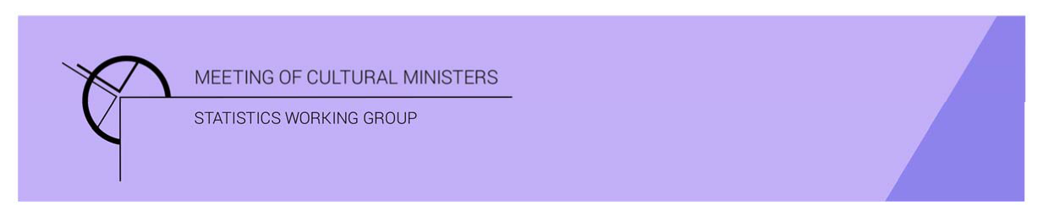

# Cultural Funding by Government—2019–20

## Australian Government

In 2019–20 the estimate of expenditure on cultural activities, funded by the Australian Government, was **$7,025.7m** representing a rise of 163% or **$4,350.8m** from 2017–18[1]. This amount included **$4,272.1m** in COVID support funding ($3,065.3m *JobKeeper* payments, $1,168.4m *Boosting Cash Flow for Employers*, $38.4m *Arts portfolio grants*) for eligible organisations, businesses, and individuals in creative and cultural industries.

The estimate of expenditure on cultural activities excluding COVID support funding was **$2,753.6m**, an increase of 3% or $78.7m from 2017–18.

Table 1. Australian Government cultural expenditure, 2016–17 to 2019–20

| 2016–17 | 2017–18 | 2019–20 | 2019–20  *Without COVID support funding* |
| --- | --- | --- | --- |
| $2,383.8m | $2,674.9m ↑12% | $7,025.7m ↑163% | $2,753.6m ↑3% |

The estimate of per person cultural funding including COVID support funding was $274.87, and without was $107.73.

### Heritage

Funds on *Heritage* activities rose 37% (or $223.2m) to $834.5m.

This increase was driven by expenditure on the categories of *Other museums and cultural heritage* (↑$162.5m), *Archives* (↑$69.9m) and *Art museums* (↑$5.9m). Conversely, funding for *Libraries* dropped $15.0m.

The categories with the highest levels of *Heritage* expenditure were *Other museums and cultural heritage* with $452.8m, followed by *Archives* with $192.0m.

Figure 1. Australian Government heritage expenditure

### Arts

The Australian Government allocated double the funding to *Arts* activities, compared to *Heritage* activities (27% and 12% respectively).

Funds for *Arts* activities decreased 7% (or $144.5m) to $1,919.1m.

The main contributors to this movement were *Community arts and cultural development* (↓$60.8m), *Theatre* (↓$44.9m), *Radio and television services* (↓$34.2m) and *Performing arts venues* (↓$20.7m).

Conversely, funding for the categories of *Film and video production and distribution* and *Literature and writing* bothincreased by $8.6m.

Funding for *Radio and television services* ($1,384.3m), accounted for almost three quarters (or 72%) of all expenditure by the Australian Government on *Arts* activities.

Other main categories of *Arts* activities funding were:

* *Film and video production and distribution*—$119.5m
* *Music*—$78.6m
* *Arts administration*—$68.1m
* *Arts education*—$50.7m
* *Visual arts and crafts*—$42.9m
* *Literature and writing*—$38.2m.

Figure 2. Australian Government highest arts expenditure categories for 2019–20

### COVID support

The Australian Government spent $4,272.1min COVID support funding for eligible organisations, businesses, and individuals in creative and cultural industries, including:

* $3,065.3m—*JobKeeper*
* $1,168.4m—*Boosting Cash Flow for Employers*
* $38.4m—*Arts portfolio grants.*

Table 2. Components of Australian Government cultural expenditure—2019–20

| Heritage | Arts | COVID support | Total |
| --- | --- | --- | --- |
| $834.5m 12% | $1,919.1m 27% | $4,272.1m61% | $7,025.7m 100% |

### Recurrent expenditure

Total recurrent expenditure rose 193% (or $4,456.5m) to $6,764.1m and accounted for 96% of total funded cultural expenditure. This included $4,272.1m in COVID support funding.[2]

The highest recurrent expenditure was for *Radio and television services* ($1,315.8m), followed by *Other museums and cultural heritage* ($328.3m).

Other main categories of recurrent expenditure were:

* *Archives*—$182.8m
* *Film and video production and distribution*—$119.4m
* *Libraries*—$81.1m
* *Music*—$77.9m
* *Arts administration*—$67.8m
* *Art museums*—$62.4m
* *Arts education*—$49.0m.

Figure 3. Australian Government recurrent cultural expenditure, by selected categories

### Capital expenditure

Capital expenditure decreased 29% (or $105.6m) to $261.6m in 2019–20 and accounted for 4% of Australian Government cultural spending.

The highest capital expenditure was for *Other museums and cultural heritage* ($124.5m), followed by *Radio and television services* ($68.6m). Other main categories of capital investment were *Art museums (*$31.5m), *Libraries (*$14.6m), *Archives* ($9.1m) and *Performing arts venues* ($6.7m).

Figure 4. Australian Government capital cultural expenditure, by selected categories

1. *Cultural Funding by Government* survey not conducted in 2018–19, as it changed to a biennial collection.
2. COVID support funding included in Total recurrent and Total figures only. COVID funding not reported by category.