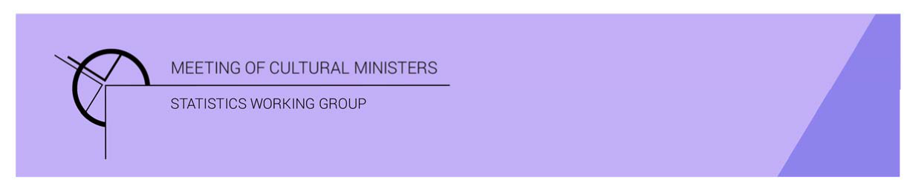

# Cultural Funding by Government—2019–20

## Australian Capital Territory Government

The estimate of expenditure funded by the Australian Capital Territory (ACT) Government in 2019–20 for cultural activities was **$89.4m**, representing an increase of 12% or $9.9m from 2017–18[1]. This amount included **$3.1m** of COVID support funding for eligible organisations, businesses, and individuals in creative and cultural industries.[2]

Table 1. ACT Government cultural expenditure, 2016–17 to 2019–20

| 2016–17 | 2017–18 | 2019–20 |
| --- | --- | --- |
| $64.9m | $79.5m ↑22% | $89.4m ↑12% |

* Recurrent expenses accounted for 82% ($73.0m) of funded cultural expenditure.
* Capital expenditure was $16.4m, and the largest two categories were *Performing arts venues* ($11.7m) and *Libraries* ($3.1m).
* The estimate of per person funding with COVID support was $208.86, and without was $201.54.

Funds on *Heritage* activities fell 14% (or $5.9m) to $35.1m.

This decrease was driven by lower expenditure on *Other museums and cultural heritage* (↓$8.8m), however expenditure on *Art museums* (↑$1.8m) and *Libraries* (↑$1.1m) both increased.

The largest categories of *Heritage* expenditure were *Libraries* with $20.8m, followed by *Other museums and cultural heritage* with $7.3m. Expenditure on *Libraries* was over half (59%) the heritage expenditure by the ACT Government.[3]

Figure 1. ACT Government heritage expenditure

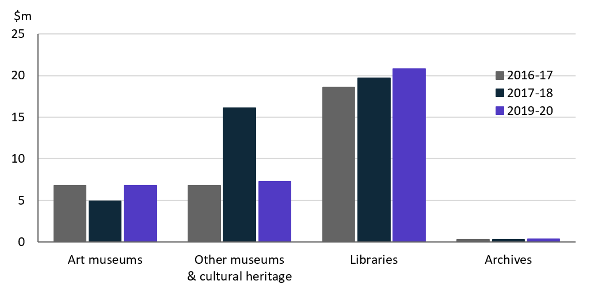

Funds for *Arts* activities rose 33% (or $12.7m) to $51.2m.

This increase was largely attributable to increases in expenditure on *Performing arts venues and Community arts and cultural development* (↑$10.8m, ↑$3.6m respectively).

Figure 2. ACT Government arts expenditure, by selected categories

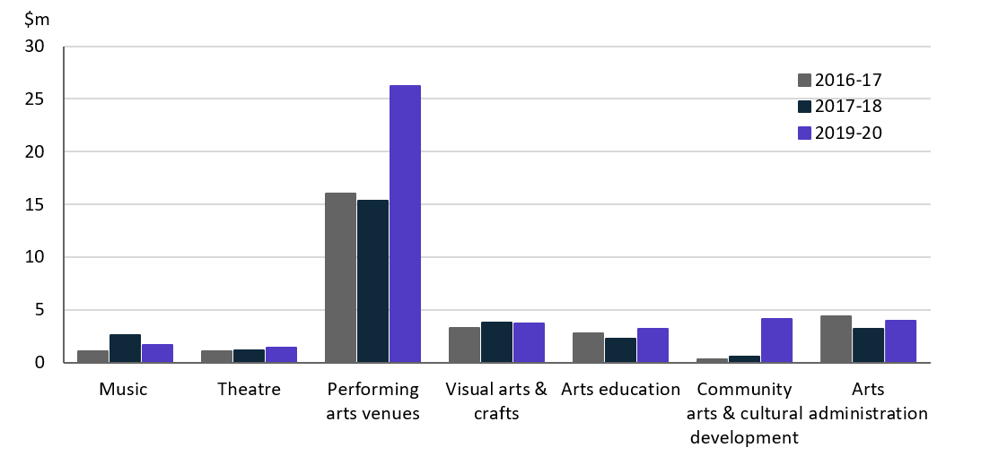

*Performing arts venues* ($26.2m), accounted for over half (51%) of all funded expenditure on *Arts* activities.

Other main categories of *Arts* activities funding were:

* *Community arts and cultural development*—$4.2m
* *Visual arts and crafts*—$3.7m
* *Arts education*—$3.3m
* *Music*—$1.8m.

Total recurrent expenditure rose 4% (or $3.0m) to $73.0m (including $3.1m for COVID support funding).[4]

The largest recurrent expenditure was for *Libraries*, $17.6m, followed by *Performing arts venues* ($14.5m). The largest dollar increase was for *Community arts and cultural development* ↑$3.3m.

Figure 3. ACT Government recurrent cultural expenditure, by selected categories

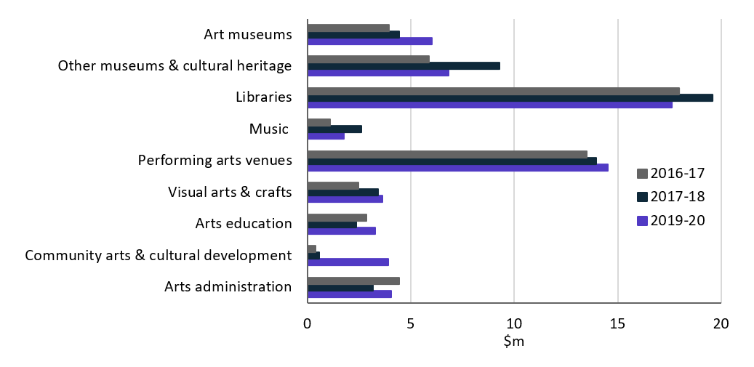

1. *Cultural Funding by Government* survey not conducted in 2018–19, as it changed to a biennial collection.
2. COVID support funding included in Total recurrent and Total figures only. COVID funding not reported by category.
3. Australian Capital Territory does not have a tier of local government with libraries funded by the ACT Government.
4. COVID support funding included in Total recurrent and Total figures only. COVID funding not reported by category.