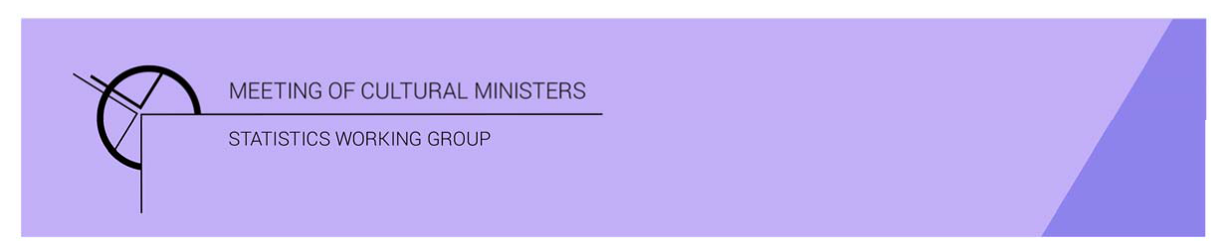

# Cultural Funding by Government — 2017–18

## Australian Capital Territory Government

The estimate of expenditure funded by the Australian Capital Territory Government in 2017–18 for cultural activities was **$79.5m**. This represented an increase of 22% or $14.6m from 2016–17.

Table 1—Australian Capital Territory Government cultural expenditure, 2015–16 to 2017–18

| 2015–16 | 2016–17 | 2017–18 |
| --- | --- | --- |
| $63.3m | $64.9m ↑ 3% | $79.5m ↑ 22% |

* Recurrent expenses accounted for 88% ($70.0m) of funded cultural expenditure.
* Capital expenditure was $9.5m, and the largest two categories were *Other museums and cultural heritage* ($6.8m) and *Performing art venues* ($1.4m).
* The estimate of per person cultural funding was $190.96.

Funds on *Heritage* activities rose 27% (or $8.6m) to $41.0m.

This increase was driven by expenditure on the categories of *Other museums and cultural heritage* (↑$9.3m) and *Libraries* (↑$1.1m). Increases were offset by a fall in *Art Museums* (↓$1.9m).

The largest categories of *Heritage* expenditure were *Libraries* with $19.7m followed by *Other museums and cultural heritage* with $16.1m. Expenditure on *Libraries* was nearly half (48%) the heritage expenditure by the Australian Capital Territory Government.

Note the ACT does not have a tier of local government and as such local government services such as libraries were instead funded by the Australian Capital Territory Government.

Figure 1. Australian Capital Territory Government heritage expenditure

Figure 1. Australian Capital Territory Government heritage expenditure.

A column graph compares expenditure across the heritage categories of Art museums, Other museums and cultural heritage, Libraries and Archives between the financial years of 2015-16, 2016-17 and 2017-18 for Australian Capital Territory Government.

Funds for *Arts* activities rose 18% (or $6.0m) to $38.5m.

This increase was largely attributable to increases in expenditure on *Film and video production and distribution* and *Music* (↑$5.0m and $1.5m respectively).

Figure 2. Australian Capital Territory Government arts expenditure, by selected categories

Figure 2. Australian Capital Territory Government arts expenditure, by selected categories.

A column graph compares expenditure across selected arts categories of Music, Performing arts venues, Cross-art form, Visual arts and crafts, Film and video production and distribution, Arts education and Arts administration between the financial years of 2015-16, 2016-17 and 2017-18 for Australian Capital Territory Government.

*Performing arts venues* ($15.4m), accounted for over one-third (40%) of all funded expenditure on *Arts* activities.

Other main categories of *Arts* activities funding were:

* *Film and video production and distribution*—$5.7m
* *Visual arts and crafts*—$3.8m
* *Music*—$2.6m
* *Arts education*—$2.4m.

Recurrent expenditure rose 23% (or $13m) to $70.0m.

The largest recurrent expenditure was for *Libraries*, $19.6m, followed by *Performing arts venues* ($13.9m).

Figure 3. Australian Capital Territory Government recurrent cultural expenditure, by selected categories

Figure 3. Australian Capital Territory Government recurrent cultural expenditure, by selected categories.

A bar chart compares recurrent expenditure across selected  categories of Art museums, Other museums and cultural heritage, Libraries, Music, Performing arts venues, Visual arts and crafts, Film and video production and distribution, Arts education and Arts administration between the financial years of 2015-16, 2016-17 and 2017-18 for Australian Capital Territory Government.

* The largest recurrent dollar increase was for the category of *Film and video production and distribution*, ↑$5.2m between 2016–17 and 2017–18.