**Review of the Protection of Movable Cultural Heritage Act 1986**

# Introduction and Background

The *Protection of Movable Cultural Heritage Act* *1986* provides Australia’s regulatory framework for the import and export of significant cultural material. It has allowed Australia to fulfil its obligations under the UNESCO *Convention on the Means of Prohibiting and Preventing the Illicit Import, Export and Transfer of Ownership of Cultural Property* 1970 and seeks to provide protection to both Australian and foreign cultural material.

Such legislation must balance the public interest in protecting cultural material with the public and private interests of property ownership and the maintenance of a legitimate trade in such material. The Minister for the Arts has appointed Australia’s pre-eminent cultural property lawyer, Mr Shane Simpson AM to conduct this important review and recommend the changes necessary to:

* deliver a balanced, more efficient, and more flexible system
* permit Australia to fulfil its international role in the protection of movable cultural property.

## Methodology of the Review

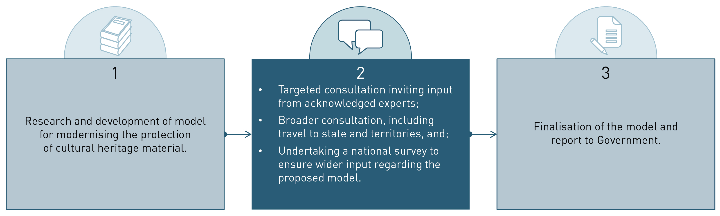

The review is currently in Stage 2. A Position Paper has been developed that describes a new model for the protection of cultural heritage. This summary document provides an overview of that Position Paper and the proposed changes.

## Invitation to comment from Mr Shane Simpson AM

In my Position Paper I set out in some detail my view as to the numerous issues that need attention with regard to the Act and how they might be best resolved. I have taken the, perhaps unusual, approach of proposing preferred models for change because I believe that this will promote more focussed and incisive comment from the sector.

I look forward to considering your comments once you have had a chance to consider the proposals described in the Position Paper. If you support an approach, tell me. If it won’t work, tell me why and how the issue can be better resolved. Similarly, if I’ve missed an issue, tell me what it is and what you think should be done. I do not promise that the final report will reflect your view but I can assure you that it will have been properly considered.

## How to provide feedback and comment

Feedback can be provided through our online survey or during the consultation process. The survey will be available on the Review’s [website](http://arts.gov.au/topics/public-consultations/review-protection-movable-cultural-heritage-act).

# Modernising the process for export control of Australian cultural material

A new classification model for cultural material

The new model provides clearer definitions of the cultural material protected by the Act, and reconfigures the National Cultural Heritage Control List to provide objective standards to define objects regulated by the Act.

It also establishes a new system of categorising cultural material as defined below.

An Australian Heritage Object (AHO) is cultural property that exceeds the relevant age and value thresholds as set out in the updated Control List. For an Australian Heritage Object an application for permit and an assessment is required.
An Australian Protected Object (APO) is an AHO that has been determined to be significant to Australia or a part of Australia, according to the new significance criteria. For an APO a permit is required and an export may be temporary or permanent.
A Declared Australian Protected Object (DAPO) receives the highest level of protection, and is an: APO that is assessed to be of such significance and is not adequately represented in Australian public collections and has therefore been denied permanent export or an object that has been declared on the DAPO list. For a DAPO permanent export is prohibited and temporary export is permitted in exceptional circumstances with conditions.


## Improvements to the export permit process

There are a number of key improvements to the features of the export process for cultural heritage material. These include:

* Improved clarity for exporters through the use of objective criteria for determining whether a permit application is necessary.
* New, transparent, flexible and shortened decision processes.
* Improved use of external experts for the assessment of permit applications and the provision of advice.
* Modernisation of enforcement powers and procedures.
* Better articulated purpose and priorities of the National Cultural Heritage Account.
* Simplification of the process for temporary export permits, including broadening eligibility for General Permits.

## Significance and Representation

The significance and representation of an object is an important part of determining whether it can be exported.

There are a number of proposed changes to significance and representation that include:

* a positive test for the determination of the significance level required to deny the export of an object
* clarification and articulation of the criteria for significance and representation assessment
* recognition of significance assessments undertaken by state and territory agencies.

For a significance assessment the primary criteria and comparative analysis criteria need to be considered in order to ascertain the level of significance of an object.
A representation assessment requires an assessment of the level of representation of objects of equivalent characteristics and quality in Australian public collections.
A decision on export will be informed by the significance assessment and the representation assessment and will be made on the basis of whether the retention of the object is important to the cultural heritage of Australia.


## Proposed export permit process

The owner/agent needs to determine whether the object is an Australian Heritage Object (AHO) through applying the new primary thresholds in the National Cultural Heritage Control List. Changes to the Control List include new thresholds for age and value, refined and coherent categories, removal of significance and representation from definitions and the minister will have the discretion to override age and value thresholds. 
If the object is not an AHO the owner may request a letter of clearance stating that no export permit is required. If the object is an AHO the applicant will then consider if the object is a Declared Australian Protected Object (DAPO), through checking the DAPO list, which contains all objects denied permanent export. If the object is a DAPO permanent export is prohibited unless an exception applies.
If the object is not a DAPO the owner/agent should check if the object is covered by a General Permit. Under the new model eligibility will be extended to other trusted organisations. If the owner/agent has a relevant general permit, temporary export is permitted and the owner/agent will be required to report the export to the department.
If the object is not covered by a General permit then the owner/agent will need to apply to the department for temporary or permanent export permit. This application will need to include detail on its current owner, the object and its provenance.
The department will then carry out its preliminary assessment. The department will be empowered to issue temporary export permits for periods of less than six months without the need for a significance assessment, unless: it is uncertain whether the object is a DAPO, or there are concerns about the potential non-return of the object. 
In clear cases the department may deny the export permit or issue an export permit, which may be subject to conditions.
If unclear the department will refer the application to two Expert Cultural Significance Assessors. The Expert’s role is to describe the significance of the object and provide information regarding representation. It is no longer the expert’s role to make recommendations as to export permission. If the assessors are unanimous in their significance assessment and the department is unconcerned with this assessment the department makes their decision on the application. If the assessors are not unanimous or if they are unanimous and the department is concerned with the assessment, the department will then seek further advice from the panel. The function of the panel is to provide flexible access to appropriate expertise and will be made up of experts from the Register of Cultural Property Experts. The department will consider the panel’s advice and make its decision.


# Enhancing the protection of foreign cultural material

A new model is proposed for the protection of foreign cultural material. This is illustrated below. The changes will increase the effectiveness and transparency of the processes to recover and return foreign cultural material. The suggested changes include:

* provisions to protect stolen and looted cultural material
* consolidation and extension of criminal sanctions
* modern law enforcement provisions that encompass a range of powers, including injunction, search and seizure powers that provide for more effective prosecution and reflect current best practice
* enhanced clarity, due diligence obligations and transparency of process
* adoption of the UNIDROIT mechanisms to give foreign claimants access to Australian courts
* retention of non-court procedure for objects stolen from inventoried collections or identified sites
* availability of an alternative dispute resolution mechanism for claimants and Australian owners
* time limitations for the bringing of claims limitations regarding claims against illegal exports to clarify expectations for importers in regard to due diligence as to title and provenance
* consolidation of processes across government for the return of looted and stolen material.

## Proposed process regarding foreign claims Object is seized on suspicion for safeguarding by the Department for a period of 3 months. This safeguarding period may be extended at any stage of these processes. The request for seizure does not need to have been made by a foreign government. If the object is not listed in the inventory of a foreign collection, monument or site, the Australian owner will have the opportunity to cede ownership. If the owner does not cede ownership the foreign claimant has a time limited period to commence legal action against the Australian owner (includes mandatory dispute resolution process). If the foreign claimant does not pursue legal action within the time period, the object is returned to the Australian owner. A different process applies if the seized object is listed in the inventory of a foreign collection, monument or site. In such cases there will be an opportunity for the foreign government and the Australian owner to provide documentation or cede ownership. The minister will then decide the appropriate action. If the minister decides to return the object to the foreign government there, will be a time limited opportunity for the Australian owner to commence proceedings to prevent forfeiture.